**Bus Tap**

Project Documentation

Submitted to the Faculty of

School of Computing and Information Technologies of

Asia Pacific College

In Partial Fulfillment of the Requirements for the Course

Applied Projects 2

By

Anna Lynn C. Alcaraz

Sammy Boy M. Angot

Justin V. Besmano

Job G. Brioso

**ASIA PACIFIC COLLEGE**

Approval Sheet

BUS TAP

Prepared and Submitted by:

Anna Lynn C. Alcaraz

Sammy Boy M. Angot

Justin V. Besmano

Job G. Brioso

In Partial Fulfilment of the Requirements for the Degree of

Bachelor of Science in

Examined and Recommended for Acceptance and Approval for Research/Capstone Presentation

\_\_\_\_\_\_\_\_\_\_\_\_\_\_\_\_\_\_\_\_\_\_\_\_\_\_\_\_\_\_

Adviser

Panel of Judges

\_\_\_\_\_\_\_\_\_\_\_\_\_\_\_\_\_\_\_\_\_\_\_\_\_\_\_\_\_\_

Chairperson

Panel Members

\_\_\_\_\_\_\_\_\_\_\_\_\_\_\_\_\_\_\_\_\_\_\_\_\_ \_\_\_\_\_\_\_\_\_\_\_\_\_\_\_\_\_\_\_\_\_\_\_\_\_

Panel Member Panel Member

Acceptance and Approved in partial fulfillment of the requirements for the degree of Bachelor of Science

\_\_\_\_\_\_\_\_\_\_\_\_\_\_\_\_\_\_\_\_\_\_\_\_\_\_\_\_\_\_

Executive Director

School of Computing and Information Technologies

**Executive Summary**

Passengers of the Bonifacio Global City (BGC) Bus have complained about the service of the BGC Bus company, mostly about how long buses take to arrive at the bus stop. When implementing a bus passenger information system, passengers perceive deduced waiting time and better service from the company. With passenger information systems, passengers are informed about the services of the company and about the arrival time of the buses.

The group created a mobile application as front-end and a web application as back-end for the Bus Tap, a passenger information system, that aims to connect the BGC Bus company to its passengers. Through the Bus Tap, the BGC Bus company can provide its passengers with the latest information regarding their services, and passengers can access up-to-date information regarding BGC Bus. Passengers can also contact the BGC Bus company through the mobile application, and provide rating, feedback, suggestions, or send inquiries, and receive replies.

With the Bus Tap reservation feature, passengers no longer have to wait long to be able to ride the bus, having been able to reserve a spot on their desired schedule ahead of time, minimizing the waiting time they experience when taking the BGC Bus.

Table of Contents

[I. Introduction 8](#_Toc510770240)

[1.1 Project Context 8](#_Toc510770241)

[1.2 Purpose and Description 8](#_Toc510770242)

[1.3 Objectives 9](#_Toc510770243)

[1.4 Scope and Limitations 9](#_Toc510770244)

[II. Review of Related Systems 9](#_Toc510770245)

[2.1 BGC Bus 9](#_Toc510770246)

[2.2 Bus Passenger Information System 12](#_Toc510770247)

[III. Technical Background 13](#_Toc510770248)

[3.1 Android 13](#_Toc510770249)

[3.2 Laravel 13](#_Toc510770250)

[IV. Design and Methodology 14](#_Toc510770251)

[4.1 Requirements Analysis 14](#_Toc510770252)

[4.2 Requirements Documentation 16](#_Toc510770253)

[4.3 Gap Analysis 16](#_Toc510770254)

[4.4 Design of Software, Systems, Product, and/or Processes 18](#_Toc510770255)

[4.4.1 Functional Description Diagram 18](#_Toc510770256)

[4.4.2 Use Case Diagram 19](#_Toc510770257)

[4.4.3 Full Use Case Description 20](#_Toc510770258)

[4.4.4 Event Table 24](#_Toc510770259)

[4.4.5 Data Flow Diagram 25](#_Toc510770260)

[4.4.6 Entity Relationship Diagram 27](#_Toc510770261)

[4.4.7 Data Dictionary 28](#_Toc510770262)

[4.4.8 Object Diagram 31](#_Toc510770263)

[4.4.9 Class Diagram 32](#_Toc510770264)

[4.4.10 Activity Diagram 33](#_Toc510770265)

[4.4.11 Sequence Diagram 38](#_Toc510770266)

[4.4.12 State Machine Diagram 44](#_Toc510770267)

[4.4.13 Timing Diagram 47](#_Toc510770268)

[4.4.14 Communication Diagram 49](#_Toc510770269)

[4.4.15 Package Diagram 50](#_Toc510770270)

[4.4.16 Component Diagram 51](#_Toc510770271)

[4.4.17 Deployment Diagram 52](#_Toc510770272)

[4.4.18 Composite Structure Diagram 53](#_Toc510770273)

[4.4.19 Interaction Overview Diagram 54](#_Toc510770274)

[4.5 Development and Testing 58](#_Toc510770275)

[4.6 Description of the Prototype 58](#_Toc510770276)

[V. Conclusions and Recommendations 60](#_Toc510770277)

[VI. References 61](#_Toc510770278)

[VII. Appendices 62](#_Toc510770279)

[7.1 Data Gathering 62](#_Toc510770280)

[Letter of Request for Interview to the management of the BGC Bus 62](#_Toc510770281)

[Questions for the Interview with the management of the BGC Bus 64](#_Toc510770282)

[Interview Transcript 65](#_Toc510770283)

[Survey Questionnaire 68](#_Toc510770284)

**List of Tables**

[Table 1. Routes and Schedules of the BGC Bus 10](#_Toc510770292)

[Table 2. Problems encountered by BGC Bus passengers 14](#_Toc510770293)

[Table 3. Average waiting time 15](#_Toc510770294)

[Table 4. Current System vs. Proposed System 16](#_Toc510770295)

**List of Figures**

[Figure 1. Screenshot of the Sign In Page of the Web Application 59](#_Toc510773816)

[Figure 2. Screenshot of the SignUp Page of the Web Application 59](#_Toc510773817)

[Figure 3. Screenshot of the View Routes Page of the Web Application 60](#_Toc510773818)

# Introduction

## Project Context

The Bus Tap is a passenger information system that will provide passengers of the BGC (Bonifacio Global City) Bus with information (e.g. news and announcements, bus routes, bus stops, operating schedule, bus schedules, and location of the buses) regarding the BGC Bus.

Using the mobile application of Bus Tap, BGC Bus passengers can view the latest news and announcements from the BGC Bus company. Passengers can view information on all the bus routes (e.g. route map, operating schedule, bus fare, and stops), bus stops (e.g. location, beep card loading availability, bus ticket availability, and routes), and bus schedules (e.g. bus number, arrival time, and departure time). Passengers will also be able to check the passenger congestion of the bus, and even reserve spots on the bus arriving closest to their selected bus schedule. Passengers can also send their rating and feedback, or inquiries regarding the BGC Bus.

Using the web application of the Bus Tap, employees of the BGC Bus company can post news and announcements to the passengers. Employees can add, view, update, and delete information regarding the bus routes, bus stops, buses, and bus schedules. Using the Bus Tap web application, the company will be able to receive reservations, rating and feedback, and inquiries sent by the passengers.

## Purpose and Description

Bonifacio Global City (BGC) is one of Manila’s Central Business Districts. Companies, especially business process outsourcing (BPO) firms, have made BGC the base of their operations in the country. With its strategic location near EDSA (Epifanio de los Santos Avenue), C-5, and SLEX (South Luzon Expressway), BGC is accessible from all points of the Metro.

To travel from, to, and within BGC, the majority relies on mass transport, mostly, the BGC Bus. The BGC bus caters to 44,000 passengers daily on weekdays, and 20,000 passengers daily on weekends (Obias, 2017). The BGC Bus has a fleet composed of 51 buses with seating capacity of 37 passengers and additional 38 standing passengers (Obias, 2017). These buses are deployed to 12 routes to help commuters navigate their way around BGC: North, North Express, East Express, Upper West Express, Lower West Express, Central, Night, East, West, Ayala Express, ARCA South Express, and Nuvali Express.

With 44,000 daily passengers, the BGC Bus company has received complaints from the passengers regarding the long queue of passengers and long waiting time during peak hours (Obias, 2017). The group conducted their own observation regarding the waiting time during peak hours. From the data gathered, the longest waiting time was about 30 minutes and 44 seconds. From the interview conducted by the group with the BGC Bus company, the company has stated that it aims to achieve a standard waiting time of 10 minutes.

The Bus Tap aims to help the BGC Bus company to achieve the standard waiting time of 10 minutes. The Bus Tap has a mobile application front-end (for the passengers) and web application back-end (for the BGC Bus company). The Bus Tap aims to build a two-way mode of communication for the company bus and its passengers.

## Objectives

The Bus Tap aims to be able to:

* build a two-way mode of communication for the bus company and its passengers; and
* decrease the waiting time of BGC Bus passengers to 10 minutes.

The Bus Tap aims to provide the passengers with information from the BGC Bus company such as the latest news and announcements from the BGC Bus company, list of bus routes and bus stops, route maps, location of the bus stops, operating schedule of each bus route, bus fare, and trip schedules. The Bus Tap also aims to allow the passengers to send their rating, feedback, and inquiries to the BGC Bus company, who can then send their replies.

The Bus Tap also aims to decrease the waiting time of passengers riding the BGC Bus to 10 minutes, as is the goal of the BGC Bus company. With the reservation feature of the Bus Tap, passengers will be able to reserve a spot ahead of time on the bus arriving at their selected bus stop on their selected time, and would only need to arrive at the bus stop at least 3 minutes before the bus arrives. Reserving a spot on the bus will allow the passengers to skip the long queues and will minimize their waiting time.

## Scope and Limitations

The Bus Tap will be available as a mobile-based application for the passengers of the BGC Bus; however, the app will only be available to Android devices. The app will also be limited to the BGC Bus. As such, locations that will be included in the app will be limited to within BGC and some areas of Makati, Taguig, and Sta. Rosa, Laguna.

# Review of Related Systems

## BGC Bus

The BGC Bus has a fleet composed of 51 buses with seating capacity of 37 passengers, but can fit a total of 75 passengers (Obias, 2017). These buses are deployed to 12 routes to help commuters navigate their way around BGC: North, North Express, East Express, Upper West Express, Lower West Express, Central, Night, East, West, Ayala Express, ARCA South Express, and Nuvali Express.

The North Route, North Express Route, East Express Route, Upper West Express Route, Lower West Express Route, Central Route, Night Route, East Route, and West Route only travel within BGC. The North Route operates from Mondays to Fridays only, from 6:30AM to 10:00AM and from 4:30PM to 8:30 PM. The North Express Route, East Express Route, Upper West Express Route, and Lower West Express Route also operates from Mondays to Fridays only, but from 6:00AM to 10:00PM. The Central Route operates every day from 6:00AM to 10:00PM, while the Night Route also operates every day from 10:00PM to 6:00AM. The West Route and the East Route operate on Saturdays, Sundays, and holidays, from 6:00AM to 10:00PM.

The extension routes, Ayala Express Route, Arca South Express Route, and Nuvali Express Route travel to Makati City, Taguig City, and Sta. Rosa, Laguna, respectively. These routes operate from Mondays to Fridays only during peak hours. Peak hours of the BGC Bus are from 6:00AM to 10:00AM and from 4:00PM to 10:00PM (Obias, 2017). The Arca South Express Route operates from 6:10AM to 9:00AM and from 4:00PM to 8:00PM. The Ayala Express Route operates only on mornings from 7:00AM to 10:00AM. The Nuvali Express Route only has one morning trip at 6:30AM, and two evening trips at 6:30PM and 7:15PM. Table 1 shows the routes and schedules of the BGC Bus:

Table 1. Routes and Schedules of the BGC Bus

|  |  |  |  |
| --- | --- | --- | --- |
| Routes | Day | Time | Stops |
| North | Weekdays | 6:30AM to 10:00AM and  4:30PM to 8:30 PM | North Station  Uptown Park Suites  Park Triangle  BGC Turf  The Globe Tower  RCBC  Net One  Bonifacio Stopover  Crescent Park West  Nutriasia  Uptown Mall  Uptown Parade |
| North Express | Weekdays | 6:00AM to 10:00PM | Edsa Ayala  HSBC  The Globe Tower  Nutriasia  BGC Turf |
| East Express | Weekdays | 6:00AM to 10:00PM | EDSA Ayala  Market! Market! |
| Central | Everyday | 6:00AM to 10:00PM | Market! Market!  One Parkade  RCBC  Net One  Bonifacio Stopover  Crescent Park West  HSBC  The Globe Tower  Nutriasia  University Parkway |
| Upper West Express | Weekdays | 6:00AM to 10:00PM | EDSA Ayala  Bonifacio Stopover  Crescent Park West |
| Lower West Express | Weekdays | 6:00AM to 10:00PM | EDSA Ayala  RCBC  Net One  Fort Victoria |
| Night | Everyday | 10:00PM to 6:00 AM | EDSA Ayala  McKinley Parkway  RCBC  Net One  Bonifacio Stopover  Crescent Park West  HSBC  The Globe Tower  Nutriasia  University Parkway  Market! Market!  One Parkade  RCBC  Net One  Bonifacio Stopover  Crescent Park West  Fort Victoria |
| East | Weekends | 6:00AM to 10:00PM | EDSA Ayala  HSBC  The Globe Tower  Nutriasia  University Parkway  Market! Market! |
| West | Weekends | 6:00AM to 10:00PM | EDSA Ayala  McKinley Parkway  RCBC  Net One  Bonifacio Stopover  Crescent Park West  Fort Victoria |
| Ayala Express | Weekdays | 7:00AM to 10:00AM | EDSA Ayala  Ritz Tower  MSE  PBCOM  RCBC Plaza  The Columns  City Gate  Security Bank  SGV Building  Glorietta 5 |
| Arca South Express | Weekdays | 6:10AM to 9:00AM and  4:00PM to 8:00PM | Arca South  Market! Market!  RCBC  Net One  Bonifacio Stopover  Crescent Park West  Nutriasia  Market! Market! |
| Nuvali Express | Weekdays | 6:30AM, 6:30PM,  and 7:15PM | Nuvali  Market! Market! |

Fare for each trip is Php 12.00 for all routes, except for Arca South Express Route and Nuvali Express Route; fare for the Arca South Express Route is Php 24.00. Tickets are not sold on board a BGC Bus. When taking the BGC Bus, passengers can either buy single-journey tickets or pay using their tap-and-go beep™ cards. Tickets are sold at cashier counters at BGC Bus terminals (e.g. Ayala, Market! Market!, and Bonifacio One Technology Tower) or from ticket sellers at selected bus stops (e.g. Bonifacio Stopover, RCBC, and Nutriasia).

## Bus Passenger Information System

A bus passenger information system allows a bus company to communicate with the bus riders (Trapeze Group). Through the passenger information system, bus companies can provide announcements, status updates, and bus schedules. With the passenger information system, passengers will know when the buses will arrive at the bus stops.

From a study of the Department for Transport of the United Kingdom, one of the benefits of implementing a passenger information system are reduced perceived waiting time (Trapeze Group). Because the passenger information system provides the schedule of the buses, passengers know when their bus will arrive.

Information can be passed to the passengers through the passenger information system in different methods: (1) wayside and transfer station signs, (2) website, (3) mobile website, (4) real-time SMS, (4) mobile applications, and (5) web services.

The Bus Tap is a passenger information system that passes information to the passengers through a mobile application. The mobile application can make the BGC Bus more accessible for new passengers, and can encourage more people to use the BGC Bus. The list of the bus routes and bus stops, map of the routes, location of the bus stop, operating schedule of the BGC Bus, bus fare, and trip schedules provided by the mobile application give new passengers all the information they need to ride the bus.

The mobile application is also a great way to connect and engage the riders. Through the mobile application, passengers can send their feedback, suggestions, and inquiries to the bus company. Through the website, the company can view the passengers’ feedbacks, suggestions, and inquiries, and be able to reply to each.

Through the Bus Tap, the company can release and update their information, and the public always has the most current information regarding their service.

# Technical Background

## Android

The mobile application of the Bus Tap is only available for Android users. The Android operating system is one of the most common operating system that is being used in the market. This type of OS can be found and is most compatible on modern devices, smartphones being the most popular. It can also be used on Smart TVs, tablets, Smart Watches, computers, and other portable gadgets.

The Android OS is a system software that manages every hardware and software running resources. The primary work of Android OS is to provide services to its host computer. It controls all application running in the gadget. Moreover, it gives access to apps especially on applications made by Google. Because of the Android OS, mobile users can play games, check the weather, check the user’s current location, play music, etc. This type of OS has its advantages over other operating system since it is easy to customize.

The Android OS is made customizable so that the phone settings would perfectly fit the taste of the user. The user can change the wallpaper, themes and launchers, unlike some operating system like IOS which make the default system private. Furthermore, a ton of application is more compatible on android compared to others.

## Laravel

The web application of the Bus Tap created using the PHP web application framework, Laravel. Laravel supports the Model View Controller (MVC) architecture. The MVC architecture separates an application into three components: the model, the view, and the controller.

The Model component corresponds to all the data-related logic that the user works with. This can represent either the data that is being transferred between the View and Controller components or any other data in the database. The View component is used for all the UI logic of the application. Controllers act as an interface between Model and View components to process all the business logic and incoming requests, manipulate data using the Model component and interact with the Views to render the final output.

# Design and Methodology

## Requirements Analysis

The group conducted an interview with the Assistant Operations Manager of the Bonifacio Transport Corporation to gather information regarding the BGC Bus (refer to Appendices for the Interview Transcript). From the interview, information regarding the BGC Bus such as available bus routes and bus stops, operating schedule, bus fare, number of buses in the fleet, passenger capacity of each bus, number of daily passengers, peak hours, peak seasons, bus route with the highest number of passengers, and passenger complaints were gathered.

The group conducted a survey amongst passengers of the BGC Bus (refer to Appendices for the Survey Questionnaire). The passengers were asked about problems encountered when riding the BGC Bus (e.g. long queue when buying bus ticket or loading beep™ card, long queue when waiting for the bus, inaccurate bus schedules, congestion of passengers inside the bus). Table 2 shows the results of the survey about the problems passengers encounter when riding the BGC Bus.

Table 2. Problems encountered by BGC Bus passengers

|  |  |  |
| --- | --- | --- |
| Problems encountered when riding the BGC Bus | Passengers who encountered  the problem | Percentage (%) out of 60 passengers |
| long queue when buying bus ticket or loading beep™ card | 5 | 8% |
| long queue when waiting for the bus | 45 | 75% |
| inaccurate bus schedules | 35 | 58% |
| congestion of passengers inside the bus | 15 | 25% |

From the results of the survey, most of the passengers do not encounter problems regarding long queue when buying bus ticket or loading beep™ card. Most of the passengers only take 1-2 minutes to buy ticket or load beep™ cards at the teller booths.

Most of the passengers also do not encounter problems regarding congestion of passengers inside the bus. Buses of the BGC Bus can accommodate 75 passengers, having a seating capacity of 37 passengers and can accommodate additional 38 standing passengers (Obias, 2017).

Passengers were also asked about the average number of minutes they usually wait for the BGC Bus. Table 3 shows the results of the survey about the average waiting time of the passengers for the BGC Bus.

Table 3. Average waiting time

|  |  |
| --- | --- |
| Average waiting time  before boarding the BGC Bus | Number of passengers |
| 1-5 minutes | 6 |
| 6-10 minutes | 5 |
| 11-15 minutes | 24 |
| 16-20 minutes | 15 |
| 21-25 minutes | 0 |
| 25-30 minutes | 5 |
| more than 30 minutes | 5 |

The goal of the BGC Bus company was to achieve a standard waiting time of 10 minutes. From the survey conducted by the group, more than half of the passengers of the BGC Bus have encountered problems regarding the long queue when waiting for the bus, with 40% having to wait for 11-15 minutes, 25% having to wait for 16-20 minutes, 8% having to wait for 25-30 minutes, and another 8% having to wait for more than 30 minutes. Out of 60 BGC Bus passengers surveyed, 81% or 49 passengers answered having to wait for the bus for longer than 10 minutes.

BGC Bus passengers were also asked if an app for the BGC Bus would be useful and which features the passengers would like the app to have. Fifty passengers or 83% answered that the passengers of the BGC Bus would find an app useful.

From the survey, passengers regard the long waiting time as the problem of the BGC Bus. The Bus Tap aims to prevent or minimize the problems encountered by the passengers of the BGC Bus. With the reservation feature provided by the Bus Tap, passengers can reserve spots to the bus ahead of time, and skip the long queues, minimizing the amount of time spent waiting for the bus.

The group observed the operations of the BGC Bus. The group bought a beep card and bus tickets to pay for the bus fare. During the group’s observation, even during rush hours, loading the beep card at the BGC Bus terminals or buying tickets at the terminals and stops do not take more than a minute. Passengers wait in line at the stops or terminals to wait for the bus to arrive. During the group’s observation, the waiting time varies. The longest waiting time the group experienced is 30 minutes and 44 seconds at the Crescent Park West stop for the bus going back to the BGC Bus Ayala Terminal. When the bus arrives, passengers ride the bus in a first-come-first-serve basis. When the bus seats are all occupied, passengers can either choose to stand inside the bus or take the next bus. The bus then takes the route it was assigned, stopping at all the stops in the route.

## Requirements Documentation

The Bus Tap must have a front-end and a back-end. The front-end of the Bus Tap must be a mobile application, accessible by the public, running using the Android operating system; thus, the mobile application must be available to Android users. The back-end of the Bus Tap must be a web application, accessible only to the employees of the BGC Bus company.

Users for both the mobile and web application must be able to sign up, sign in, and sign out of their accounts. Users must also be able to request for a change of password

Users of the mobile application (passengers) must be able to view the latest news updates from the BGC Bus company, view the map of BGC with the location of all the bus stops and several points of interest within BGC, view information regarding the bus routes and bus stops, view the bus schedules, view the passenger congestion, reserve a spot in the bus arriving closest to their selected trip, provide rating, feedback, suggestions, and inquiries to the company, and receive replies from the company.

Users of the web application (employees) must be able to add, view, update, and delete information regarding bus routes, bus stops, buses, bus schedules, news updates, and passenger congestion. Employees must also receive the reservations made by the passengers. The company must also be able to view the passengers’ ratings, feedbacks, suggestions, and inquiries, and be able to reply.

## Gap Analysis

Table 4. Current System vs. Proposed System

|  |  |  |  |
| --- | --- | --- | --- |
| **User Requirements** | **Current System** | **Proposed Changes** | **Remarks/Impact** |
| The system must be able to show accurate BGC Bus trip schedule like minutes to wait, estimated time of arrival and departure times. | BGC Bus company has inaccurate trip schedule that resulted to increased waiting time for all BGC Bus passengers. | Provide a more accurate system in terms of showing data regarding arrival and departure times. Improve overall waiting time. | Improved average waiting time by less than 10 minutes. |
| The system must be able to show all nearest bus stops based on user’s location. | The functionality is not currently available now. | Show all nearest bus stop based on user’s location and view information regarding the preferred bus stop. | Users will be more knowledgeable regarding their current location and be guided by all bus stops available. |
| The system must have a news feature that would allow users to be well informed about the current situation. | The news feature of the current system is not real time, making the spreading of news late and slow. | Provide a real-time news feature that would allow all users about the current happenings and current problems at the most present time. | BGC Bus passengers will become well informed about the current situation. Moreover, transparency between the company and the passengers will become more evident. |
| The system must have a report issue/concern feature. | Reporting concerns and sending issues are available but can only be accessed through SMS or via phone call. | Produce a more reliable functionality that would make use of internet connection instead of SMS. | Viewing reports and issues from the passengers will be available since user concerns and reports will be stored in a database. |
| Forecast the number of passengers per bus stop. | Congestion Forecast cannot be viewed by the BGC Bus passenger. | Produce a forecast that is readily available for the passengers. This would allow passengers to choose their preferred less congested stop or take an alternate route. | Knowledgeable about the current situation in a specific bus stop. |
| The system must have a reservation feature. | This is not available for the current system. | Make a reservation feature that would allow passengers to reserve a spot in a specific bus. | This would be a solution for controlling long queue lines in bus stops. |

## Design of Software, Systems, Product, and/or Processes

### Functional Description Diagram

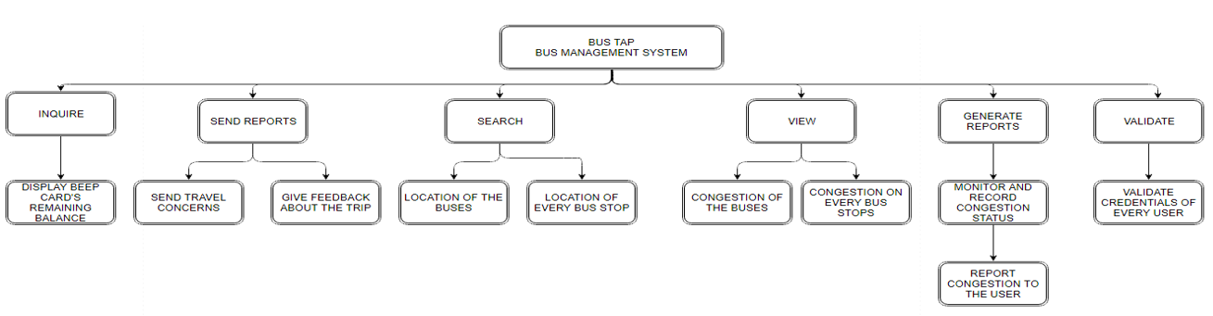

### Use Case Diagram

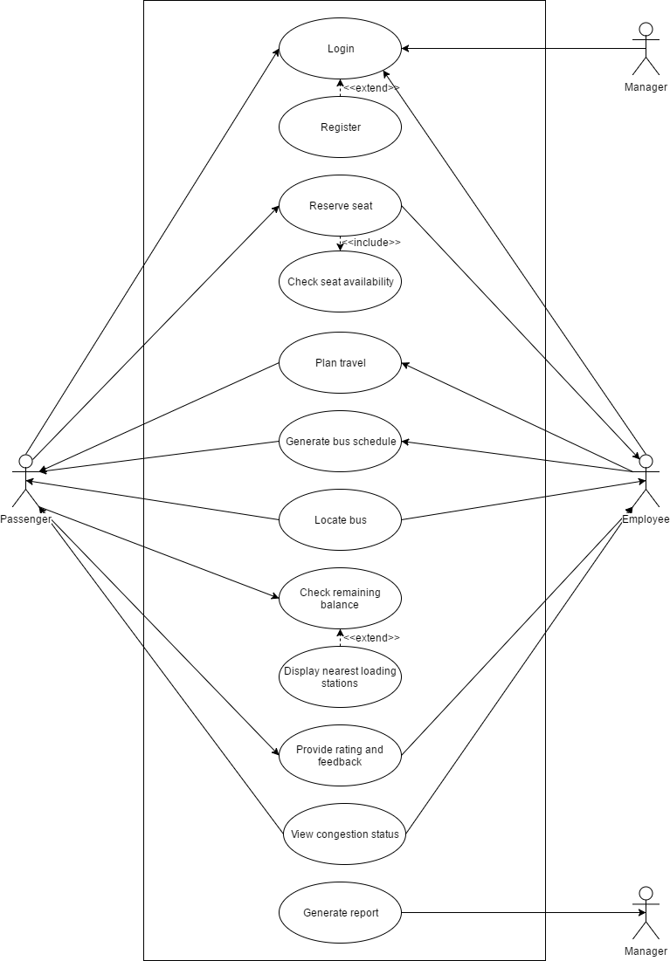

### Full Use Case Description

|  |  |  |
| --- | --- | --- |
| Use Case Name: | **Login (Passenger)** | |
| Scenario: | **Passenger logs in to their Bus Tap account.** | |
| Triggering Event: | **Passenger entered their login details on the login page of the app.** | |
| Brief Description: | **When passenger logs in to their account, the system validates that the login details entered by the passenger matches the login details of an existing Bus Tap account.** | |
| Actors: | **Passenger** | |
| Related Use Case: | **Login (Employee), Login (Manager)** | |
| Stakeholders: | **Passenger – provides the login details** | |
| Preconditions: | **Passenger must have an existing Bus Tap account** | |
| Postconditions: | **Passenger is logged in.** | |
| Flow of Activities: | Actor | System |
| 1. **Passenger requests the login page of the app.** 2. **Passenger enters the registered email address and corresponding password.** | * 1. **System displays the login page.**   2. **Validate data input**   3. **Match email address and password to an existing account**   4. **Log in passenger**   5. **Display passenger information** |
| Exception Conditions: | 1. **If email address entered does not match any existing accounts, redirect to sign-up interface or forgot username interface.** 2. **If password entered does not match the email address, redirect to forgot password interface.** 3. **Users are only given 10 chances to enter their correct login details at a time.** | |

|  |  |  |
| --- | --- | --- |
| Use Case Name: | **Reserve seat** | |
| Scenario: | **Passenger reserves a spot on a BGC Bus.** | |
| Triggering Event: | **Passenger entered travel details on the seat reservation page of the app.** | |
| Brief Description: | **When passenger wants to reserve a spot on the BGC Bus, the system displays the bus schedules, and the passenger can reserve a spot.** | |
| Actors: | **Passenger**  **Driver** | |
| Related Use Case: |  | |
| Stakeholders: | **Passenger – provides date and time of travel, bus stop; selects the bus schedule;**  **Driver – reserves the bus seat** | |
| Preconditions: | **Passenger must be logged in to their Bus Tap account.** | |
| Postconditions: | **A seat is reserved for the passenger.** | |
| Flow of Activities: | Actor | System |
| 1. **Passenger requests the seat reservation page of the app.** 2. **Passenger enters the date, time, and the bus stop.** 3. **Passenger selects the bus schedule.** | * 1. **System displays the seat reservation page of the app.**   2. **System displays the available schedules closest to the travel details entered by the passenger.**   3. **System reserves a spot on the bus arriving closest to the schedule.** |

|  |  |  |
| --- | --- | --- |
| Use Case Name: | **Generate bus schedules** | |
| Scenario: | **Manager should be able to generate bus schedule so that user would be able to view all bus schedules** | |
| Triggering Event: | **Viewing of travel details** | |
| Brief Description: | **The passenger should be able to view the bus schedule generated by the manager** | |
| Actors: | **Logged in Passenger Manager** | |
| Related Use Case: | **Logging of accounts** | |
| Stakeholders: | **Manager – the one who will update the bus schedules Logged passengers – the one who will view the schedules** | |
| Preconditions: | **Bus schedule data should be available Passenger should be logged in to view the details** | |
| Postconditions: | **The logged in passenger should be able to view all details regarding bus schedules** | |
| Flow of Activities: | Actor | System |
| 1. **User requests to view the bus schedules of the bus** | * 1. **The system should be able to validate the credentials of the user before giving the schedules**   2. **The system should be able to display all the bus schedule** |
| Exception Conditions: | 1. **Bus schedule should be available, if not, the manager or administrator should provide** | |

|  |  |  |
| --- | --- | --- |
| Use Case Name: | **Rate and provide feedback** | |
| Scenario: | **The passenger wants to give feedback regarding the user’s trip** | |
| Triggering Event: | **User feedback** | |
| Brief Description: | **The passenger should be able to give feedback and rate regarding his/her trip** | |
| Actors: | **Logged in Passenger** | |
| Related Use Case: | **Log in** | |
| Stakeholders: | **Logged in passenger – the one who will give feedback** | |
| Preconditions: | **Users must be successfully logged in to their accounts** | |
| Postconditions: | **The rate and feedbacks should be able to go to the database** | |
| Flow of Activities: | Actor | System |
| 1. **User will rate the driver and his/her overall trip** 2. **User will give feedbacks** | **1.1 Validate the credentials of the user**   * 1. **Rating page would show up**   **1.3 Allow the user to rate his/her travel**  **1.4 Save it to the system’s database**   * 1. **Validate the credentials of the user**   2. **Feedback page should show up**   3. **Allow the user to give feedback**   4. **Save the feedback of the user** |
| Exception Conditions: | **The user should be registered, if not, redirect to create account and log in page.** | |

### Event Table

|  |  |  |  |  |  |
| --- | --- | --- | --- | --- | --- |
| **EVENT** | **TRIGGER** | **SOURCE** | **USE CASE** | **RESPONSE** | **DESTINATION** |
| Passenger logged in to Bus Tap account | Login details | Passenger | Login | Passenger information | Manager |
| Passenger wants to reserve a spot on a BGC Bus | Reservation request | Passenger | Reserve | Reservation details | Passenger |
| Passenger wants to know the available bus schedules | Travel details | Passenger | Generate bus schedules | Bus schedules | Passenger |
| Passenger wants to rate the facilities and services of the BGC Bus and provide a feedback | Travel details, rating, feedback | Passenger | Rate and provide feedback | Rating and feedback | Employee |
| Manager wants to generate a report about the BGC Bus. | Report request | Manager | Generate report | Report | Manager |

### Data Flow Diagram

Data Flow Diagram Context Diagram

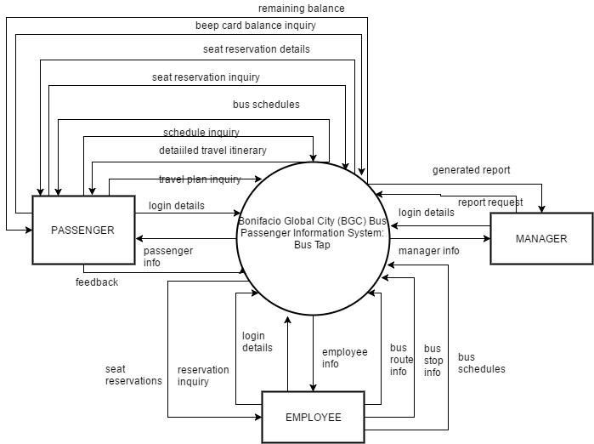

Data Flow Diagram Level 1

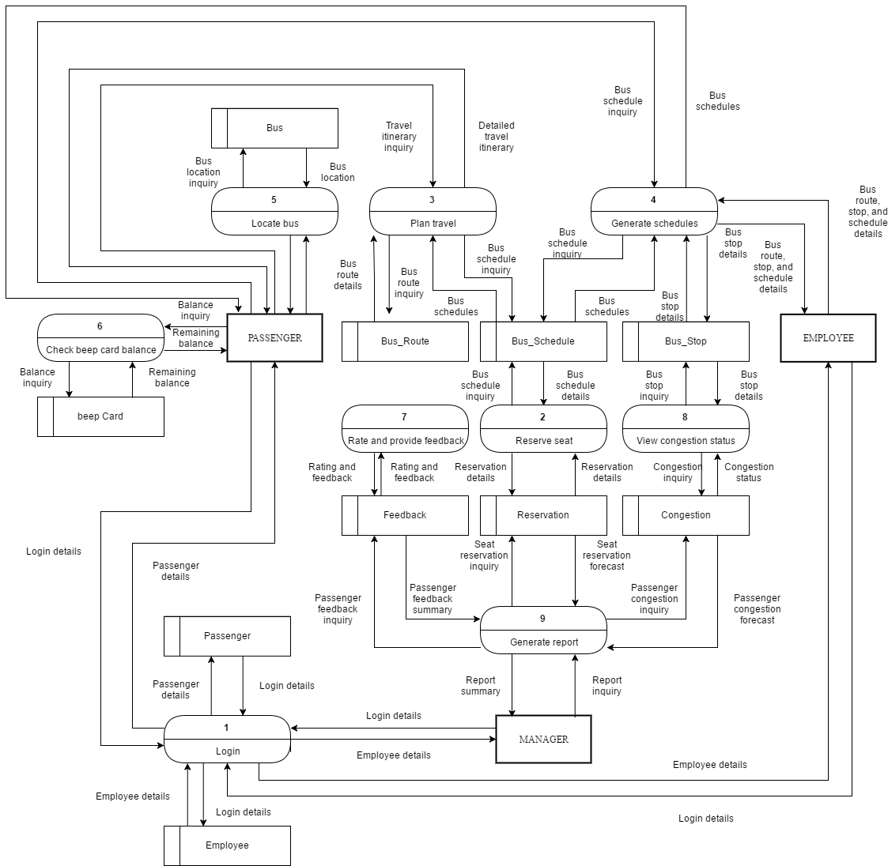

### Entity Relationship Diagram

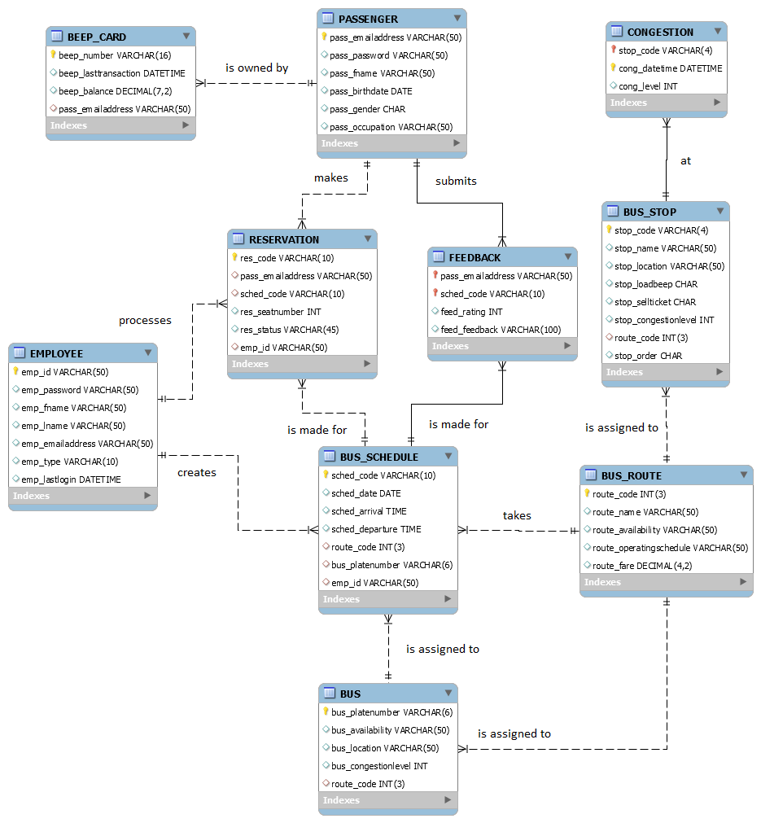

### Data Dictionary

|  |  |
| --- | --- |
| **ENTITY: BEEP\_CARD** | |
| **Attribute Name** | **Data Type** |
| beep\_number | VARCHAR(16) |
| beep\_lasttransaction | DATETIME |
| beep\_balance | DECIMAL(7,2) |
| pass\_mobilenumber | VARCHAR(11) |

|  |  |
| --- | --- |
| **ENTITY: PASSENGER** | |
| **Attribute Name** | **Data Type** |
| pass\_emailaddress | VARCHAR(50) |
| pass\_password | VARCHAR(50) |
| pass\_fname | VARCHAR(50) |
| pass\_lname | VARCHAR(50) |
| pass\_birthdate | DATE |
| pass\_gender | CHAR |
| pass\_occupation | VARCHAR(50) |

|  |  |
| --- | --- |
| **ENTITY: RESERVATION** | |
| **Attribute Name** | **Data Type** |
| res\_code | VARCHAR(10) |
| pass\_emailaddress | VARCHAR(50) |
| sched\_code | VARCHAR(10) |
| res\_seatnumber | INT |
| res\_status | VARCHAR(45) |
| emp\_id | VARCHAR(50) |

|  |  |
| --- | --- |
| **ENTITY: FEEDBACK** | |
| **Attribute Name** | **Data Type** |
| pass\_emailaddress | VARCHAR(50) |
| sched\_code | VARCHAR(10) |
| feed\_rating | INT |
| feed\_feedback | VARCHAR(100) |

|  |  |
| --- | --- |
| **ENTITY: BUS** | |
| **Attribute Name** | **Data Type** |
| bus\_platenumber | VARCHAR(6) |
| bus\_availability | VARCHAR(50) |
| bus\_location | VARCHAR(50) |
| bus\_congestionlevel | INT |
| route\_code | INT(3) |

|  |  |
| --- | --- |
| **ENTITY: BUS\_SCHEDULE** | |
| **Attribute Name** | **Data Type** |
| sched\_code | VARCHAR(10) |
| sched\_date | DATE |
| bus\_platenumber | VARCHAR(6) |
| route\_code | INT(3) |
| sched\_arrival | TIME |
| sched\_departure | TIME |
| emp\_id | VARCHAR(50) |

|  |  |
| --- | --- |
| **ENTITY: EMPLOYEE** | |
| **Attribute Name** | **Data Type** |
| emp\_id | VARCHAR(50) |
| emp\_password | VARCHAR(50) |
| emp\_fname | VARCHAR(50) |
| emp\_lname | VARCHAR(50) |
| emp\_emailaddress | VARCHAR(50) |
| emp\_type | VARCHAR(10) |
| emp\_lastlogin | DATETIME |

|  |  |
| --- | --- |
| **ENTITY: BUS\_ROUTE** | |
| **Attribute Name** | **Data Type** |
| route\_code | INT(3) |
| route\_name | VARCHAR(50) |
| route\_availability | VARCHAR(50) |
| route\_operatingschedule | VARCHAR(50) |
| route\_fare | DECIMAL(4,2) |
| **ENTITY: BUS\_STOP** | |
| **Attribute Name** | **Data Type** |
| stop\_code | VARCHAR(4) |
| stop\_name | VARCHAR(50) |
| stop\_location | VARCHAR(50) |
| stop\_loadbeep | CHAR |
| stop\_sellticket | CHAR |
| stop\_congestionlevel | INT |
| route\_code | INT(3) |
| stop\_order | INT |

|  |  |
| --- | --- |
| **ENTITY: CONGESTION** | |
| **Attribute Name** | **Data Type** |
| stop\_code | VARCHAR(4) |
| cong\_datetime | DATETIME |
| cong\_level | VARCHAR(10) |

### Object Diagram

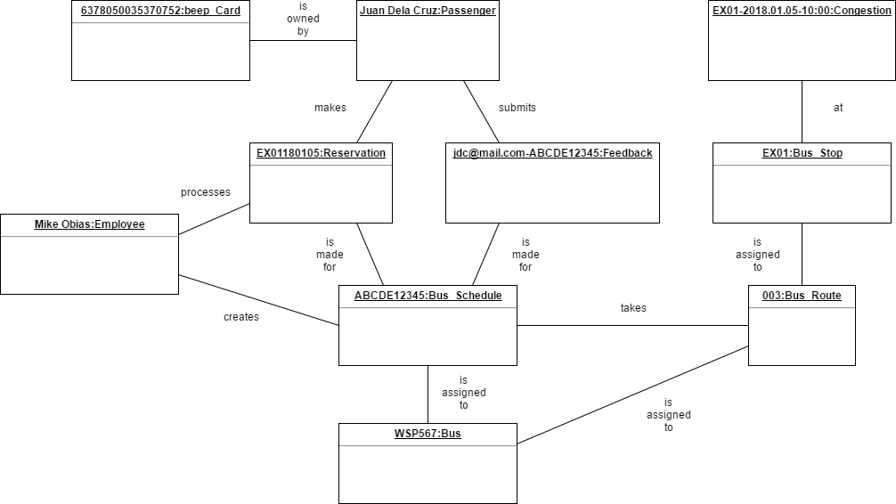

### Class Diagram

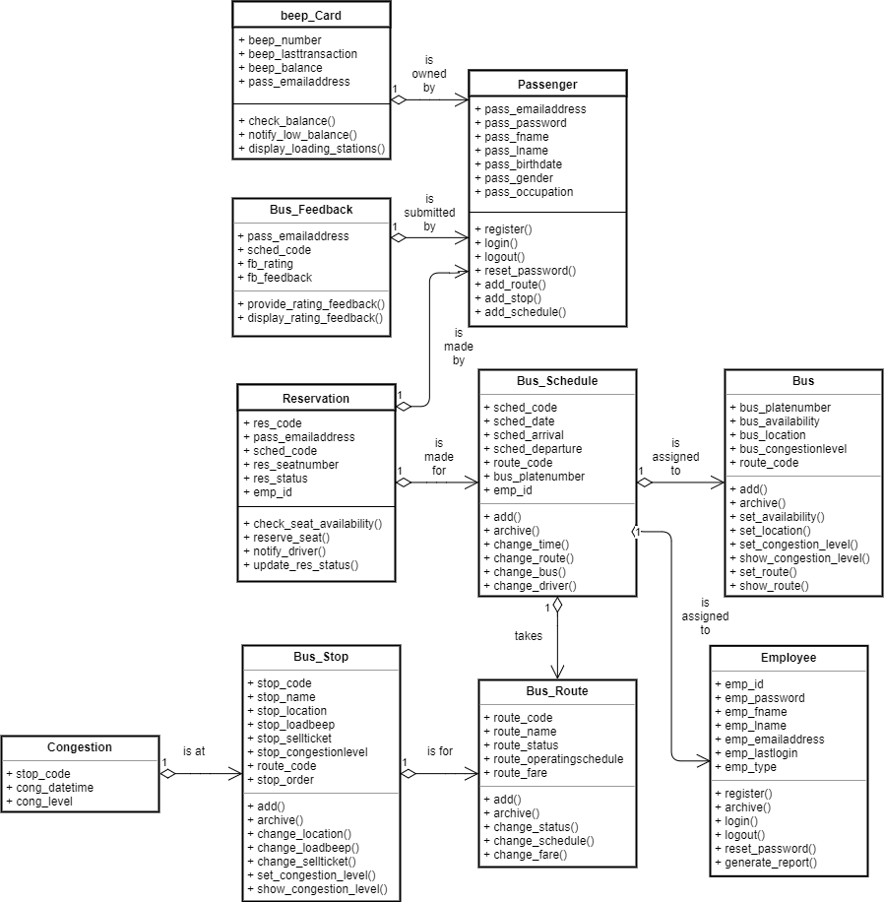

### Activity Diagram

Activity diagram for Use Case: Login

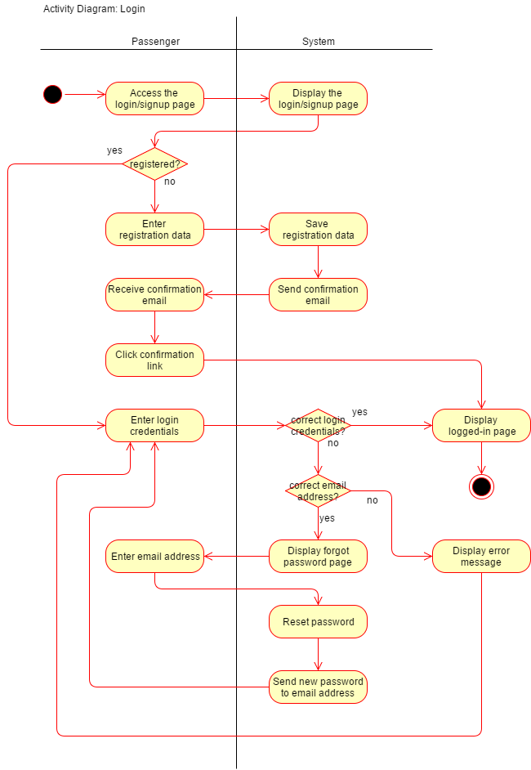

Activity diagram for Use Case: Reserve seat

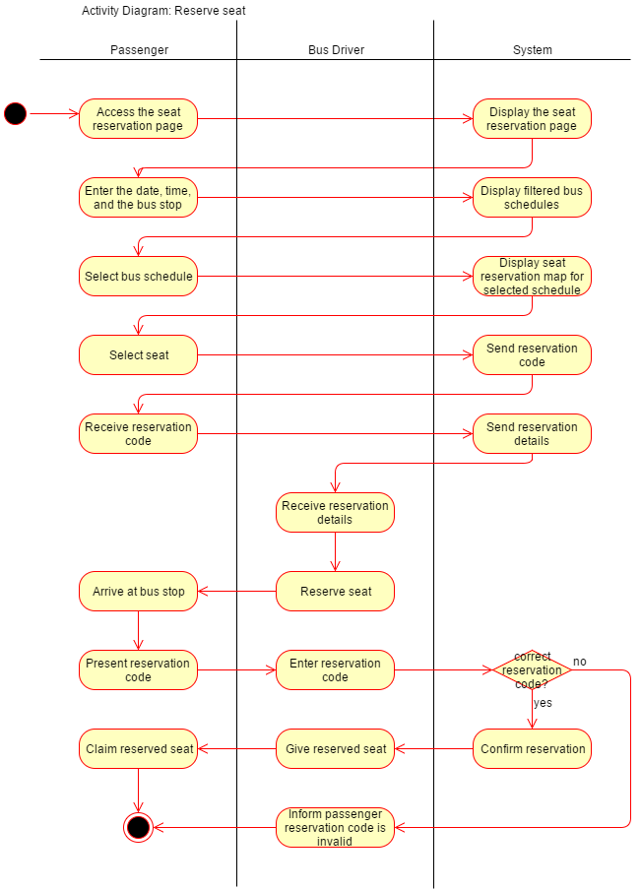

Activity diagram for Use Case: Generate bus schedules

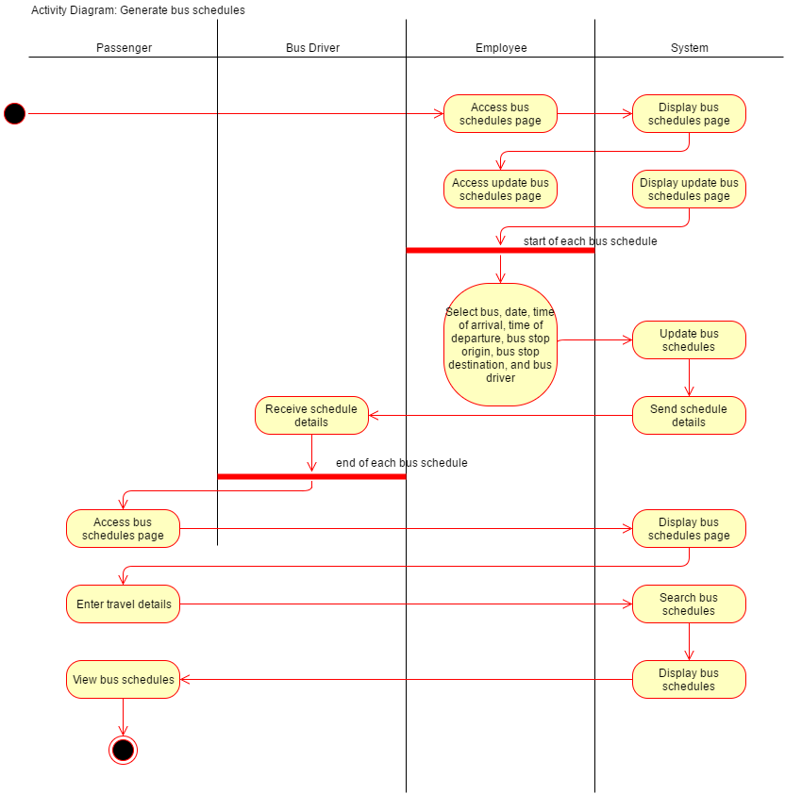

Activity diagram for Use Case: Locate bus

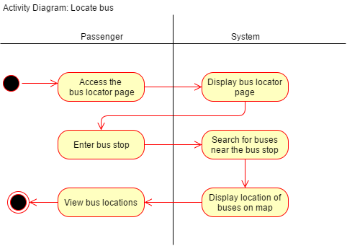

Activity diagram for Use Case: Rate and provide feedback

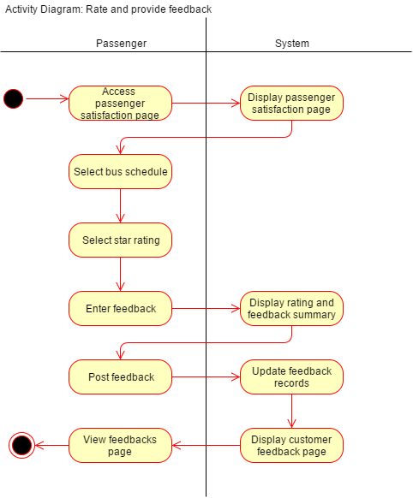

### Sequence Diagram

Sequence diagram for Use Case: Login

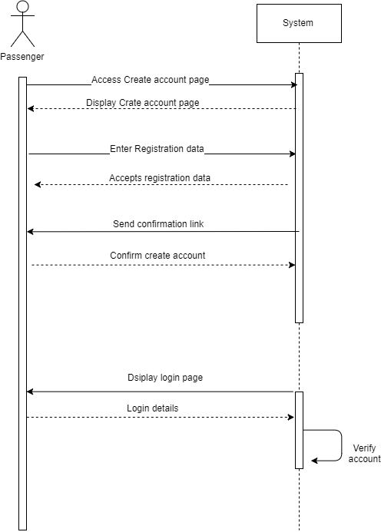

Sequence diagram for Use Case: Reserve seat

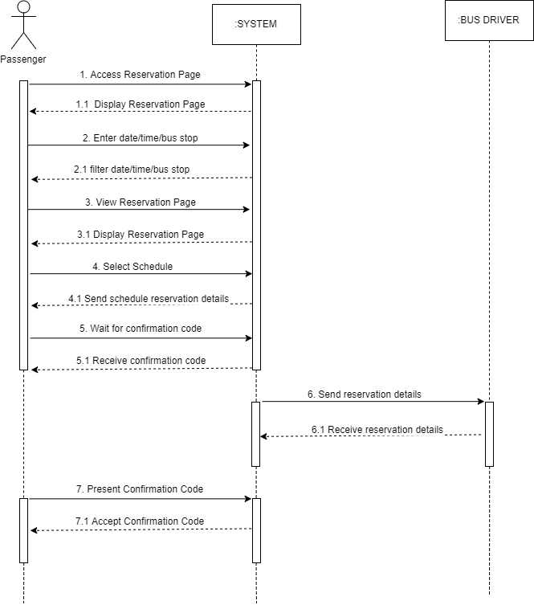

Sequence diagram for Use Case: Generate bus schedules (employee)

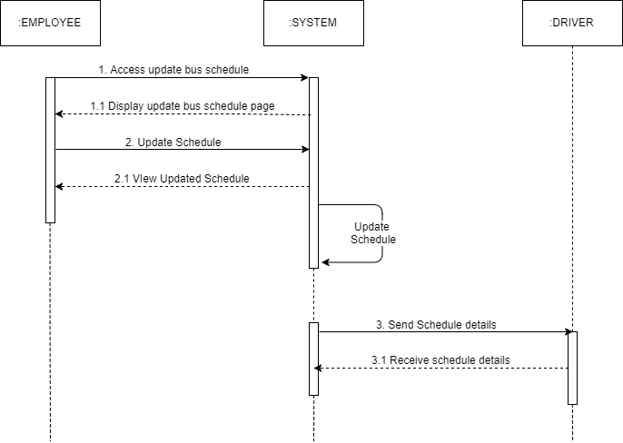

Sequence diagram for Use Case: Generate bus schedules (passenger)

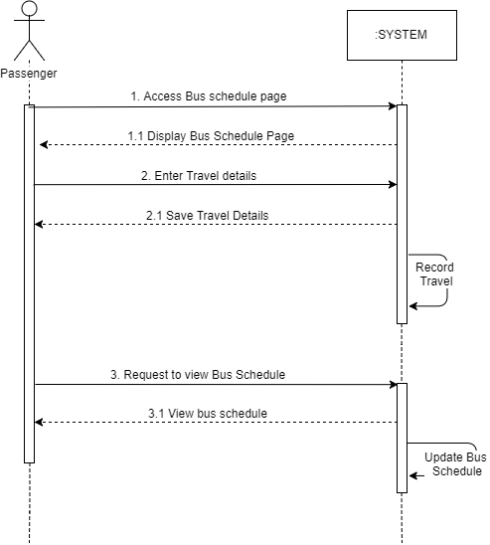

Sequence diagram for Use Case: Rate and provide feedback

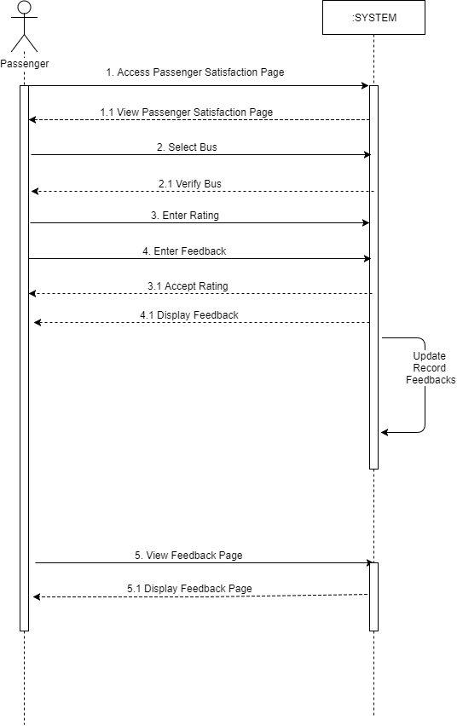

Sequence diagram for Use Case: Generate report

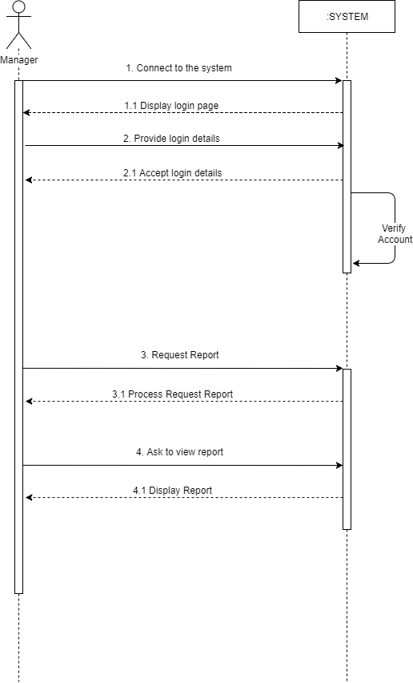

### **State Machine Diagram**

State Machine diagram for Object: Passenger

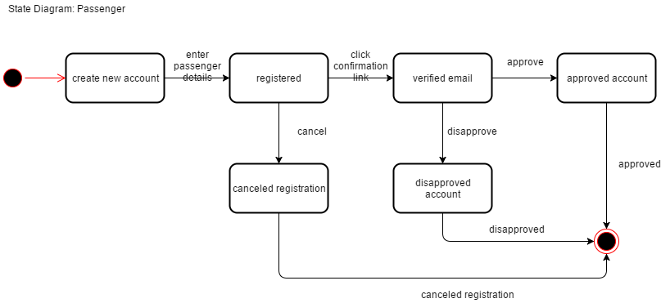

State Machine diagram for Object: Reservation

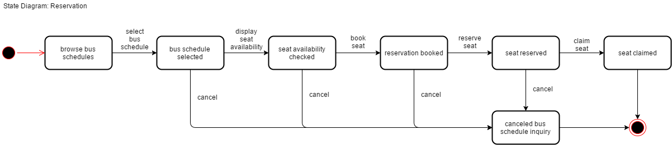

State Machine diagram for Object: Feedback

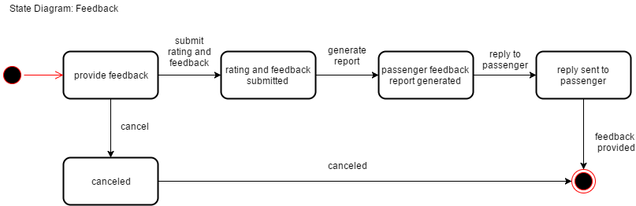

State Machine diagram for Object: Bus

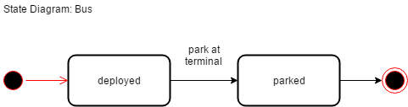

State Machine diagram for Object: Bus Schedule

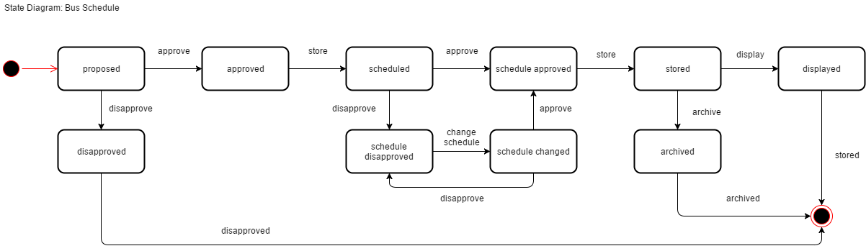

State Machine diagram for Object: Employee

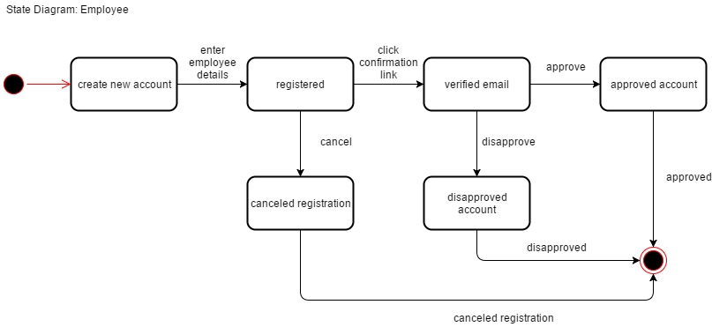

State Machine diagram for Object: Bus Route

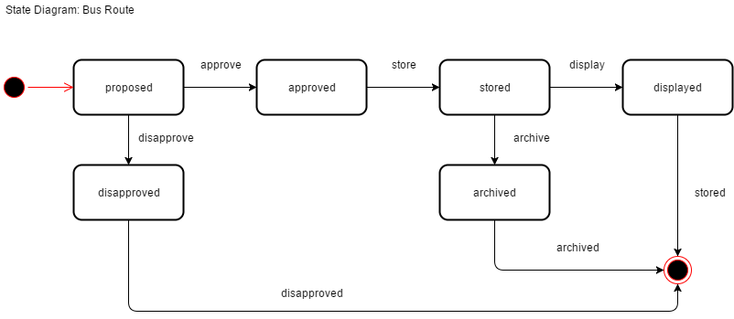

State Machine diagram for Object: Bus Stop

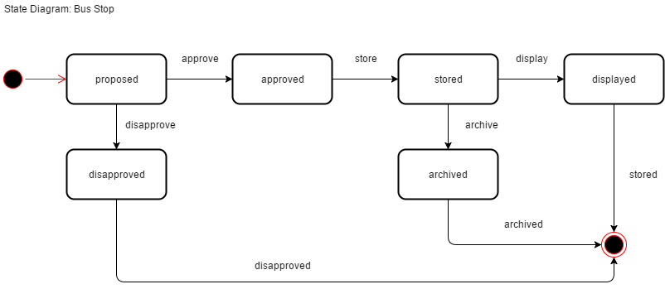

### **Timing Diagram**

Timing diagram for Object: Passenger

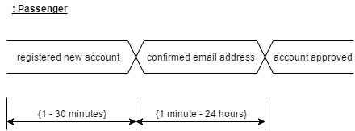

Timing diagram for Object: Reservation

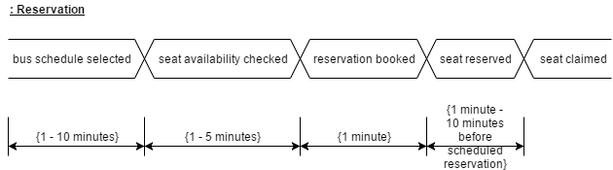

Timing diagram for Object: Feedback

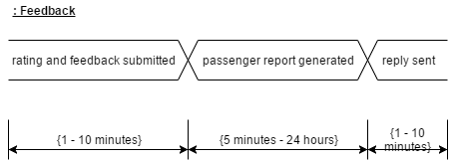

Timing diagram for Object: Bus

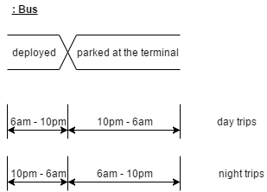

Timing diagram for Object: Employee

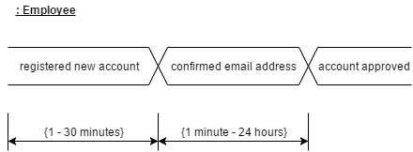

### **Communication Diagram**

Communication diagram for Use Case: Reserve seat

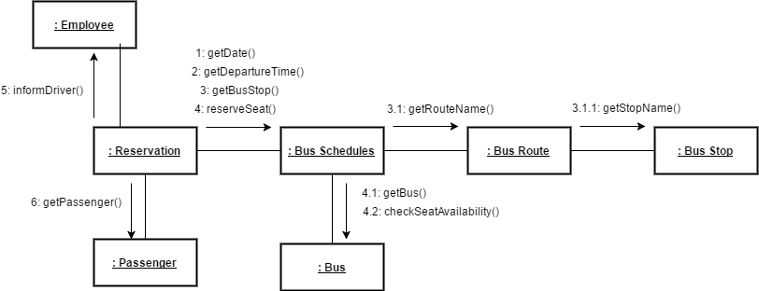

Communication diagram for Use Case: Plan travel

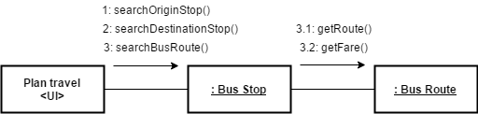

Communication diagram for Use Case: Display bus schedules

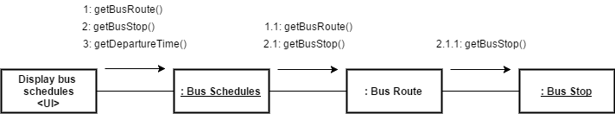

### **Package Diagram**

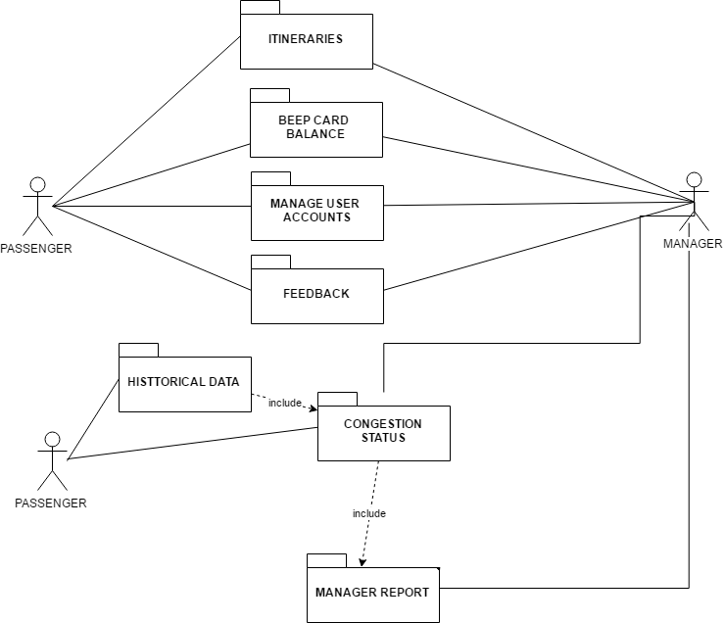

### **Component Diagram**

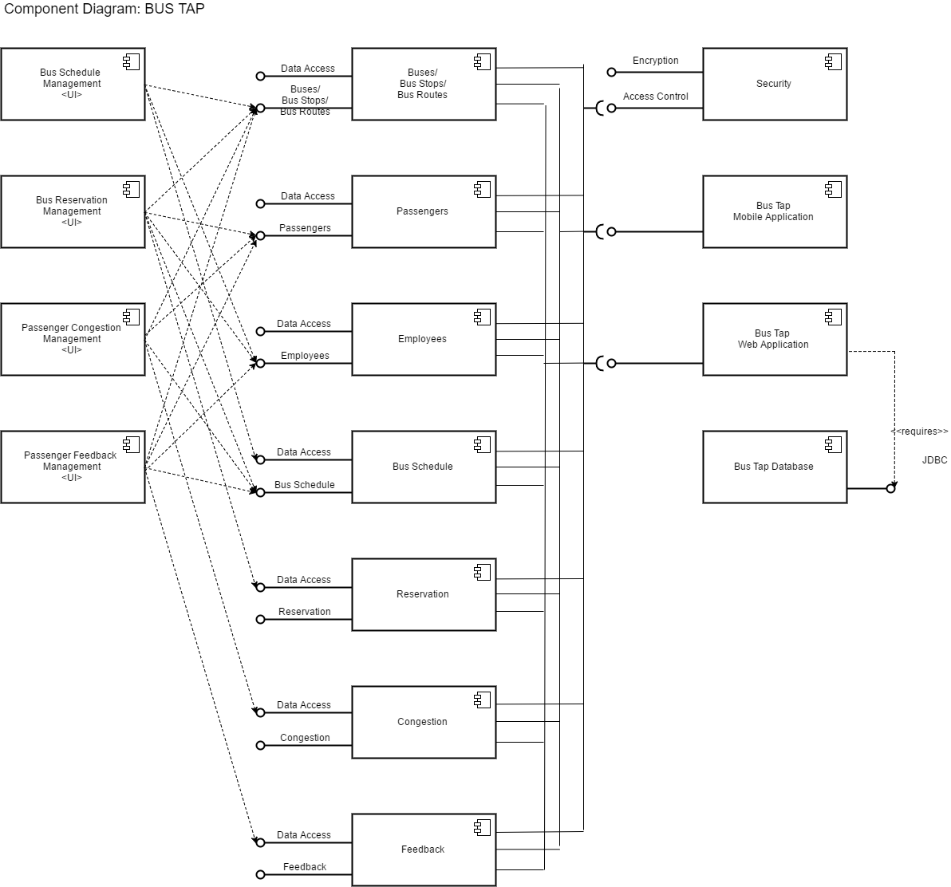

### **Deployment Diagram**

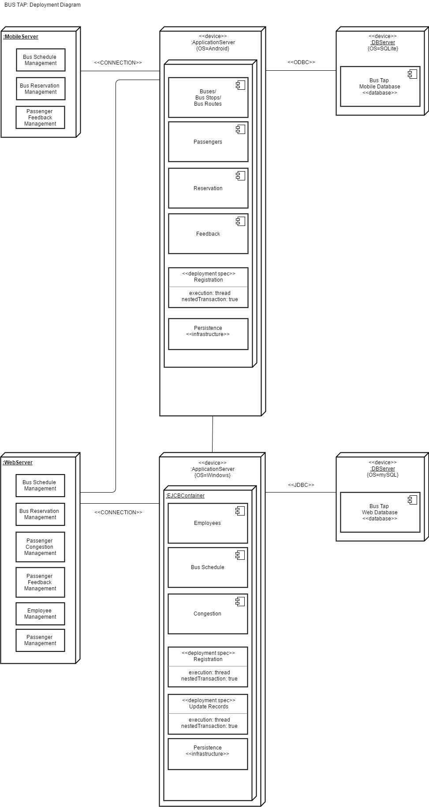

### **Composite Structure Diagram**

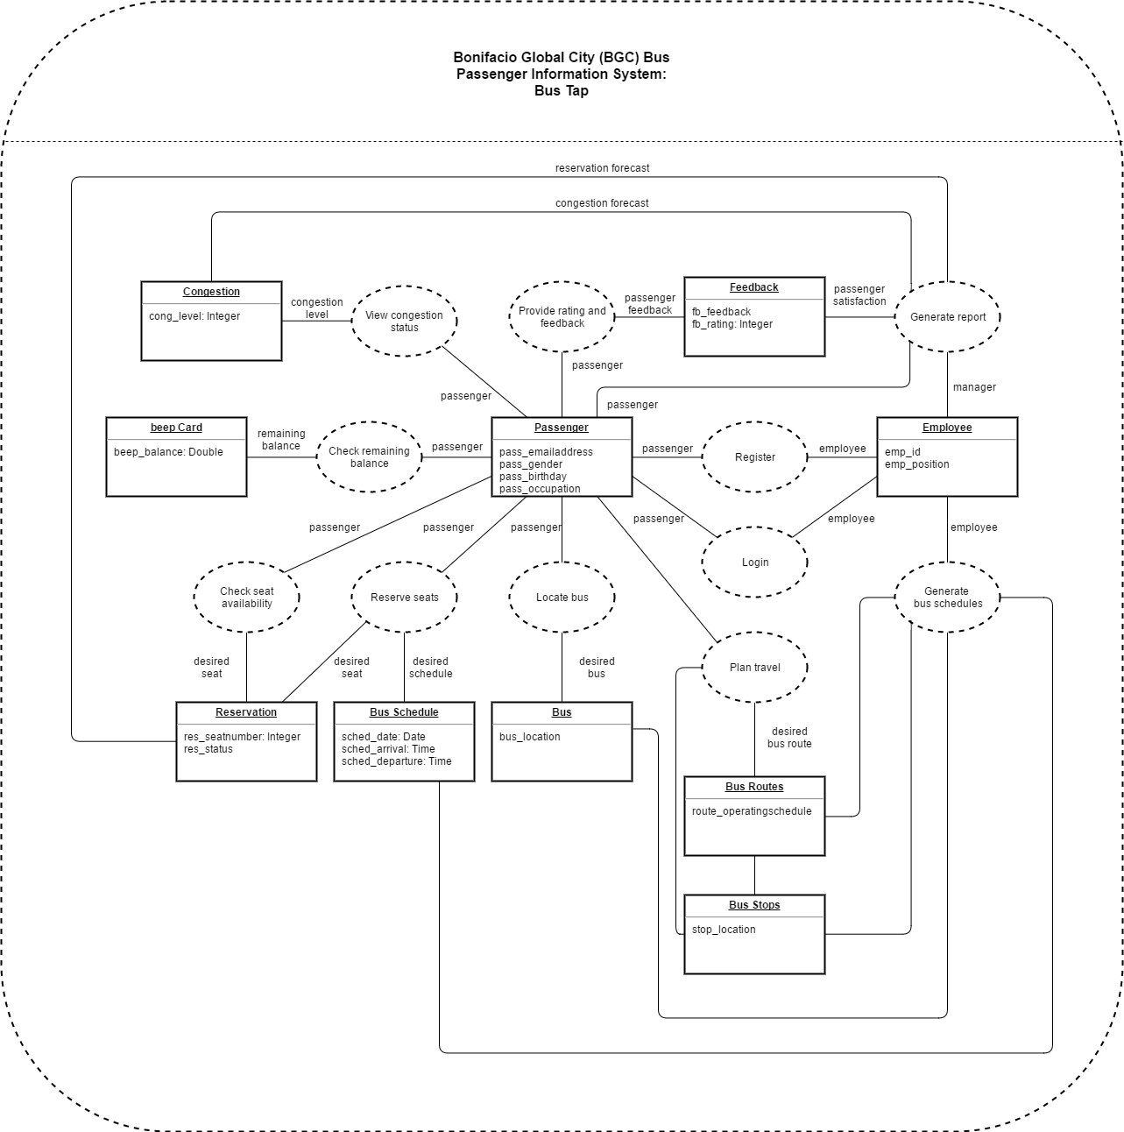

### **Interaction Overview Diagram**

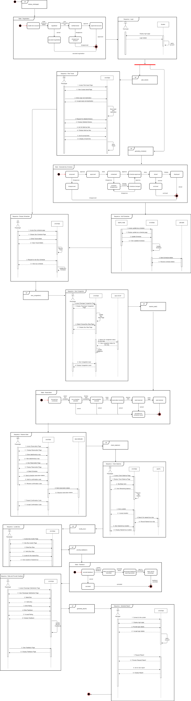

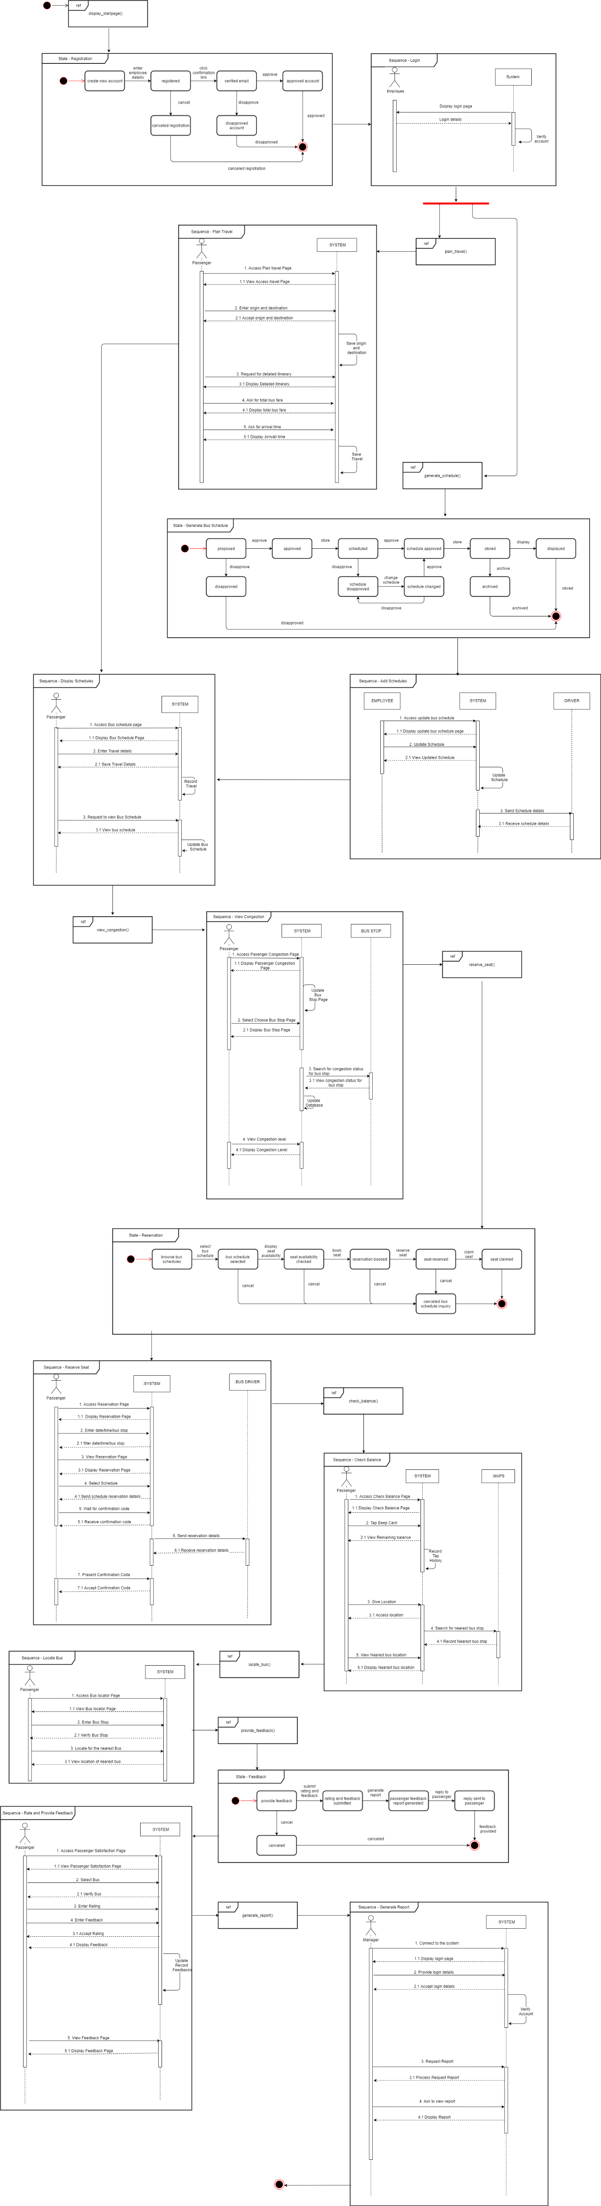





## Development and Testing

The mobile application was developed using the Android Studio IDE. The web application was developed using the Visual Studio Code IDE. The web application runs via localhost of the computer. Database of the website also runs via localhost of the computer.

## Description of the Prototype

The mobile application of the Bus Tap consists of the

* Welcome Page,
* Sign In Page,
* Sign Up Page,
* Forgot Password Page,
* Menu Page,
* News Page,
* Maps Page,
* Routes Page,
* Feedback Page, and
* Reservation Page.

The web application of the Bus Tap consists of the

* Sign In Page,
* Sign Up Page,
* Reset Password Request Page,
* Reset Password Page,
* Home Page
* Bus Routes Page (View All, Add, Update, and View One)
* Bus Stops Page (View All, Add, Update, and View One)
* Buses Page (View All, Add, Update, and View One)
* Bus Schedules Page (View All, Add, Update, and View One)
* News Page (View All, Add, Update, and View One)
* View Rating and Feedback Page

The Sign Up Page, Sign In Page, Reset Password Page, and Reset Password Request Page allows of the mobile and web application allows the users to create an account and to access them. The Menu Page of the mobile application and the Home Page of the web application allows users to access the different pages upon signing in. The News Page, Routes Page, Bus Stops Page, Buses Page, and Bus Schedules Page allows the employee to post news, route information, stop information, bus information, and trip information and the passengers to view the posts. The Feedback Page allows the passengers to provide rating and feedback, which can be seen by the company. The Reservation Page allows the passengers to make a reservation and for the company to receive the reservation.

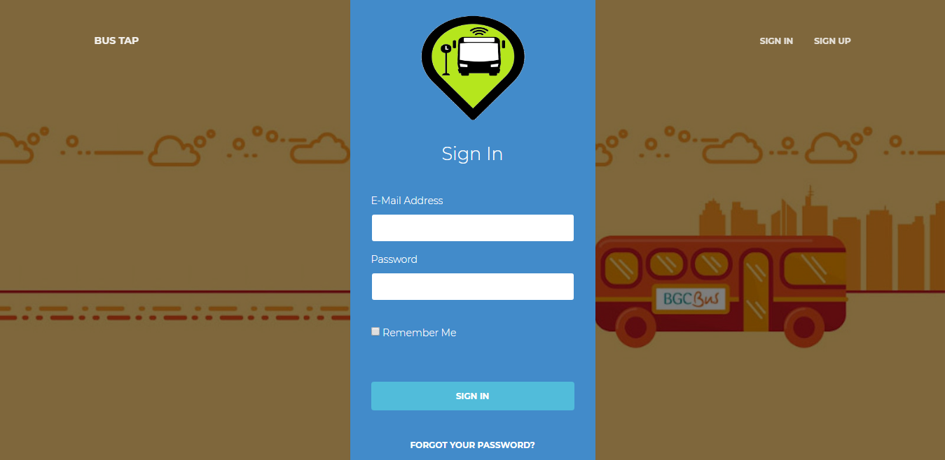

Figure 1. Screenshot of the Sign In Page of the Web Application

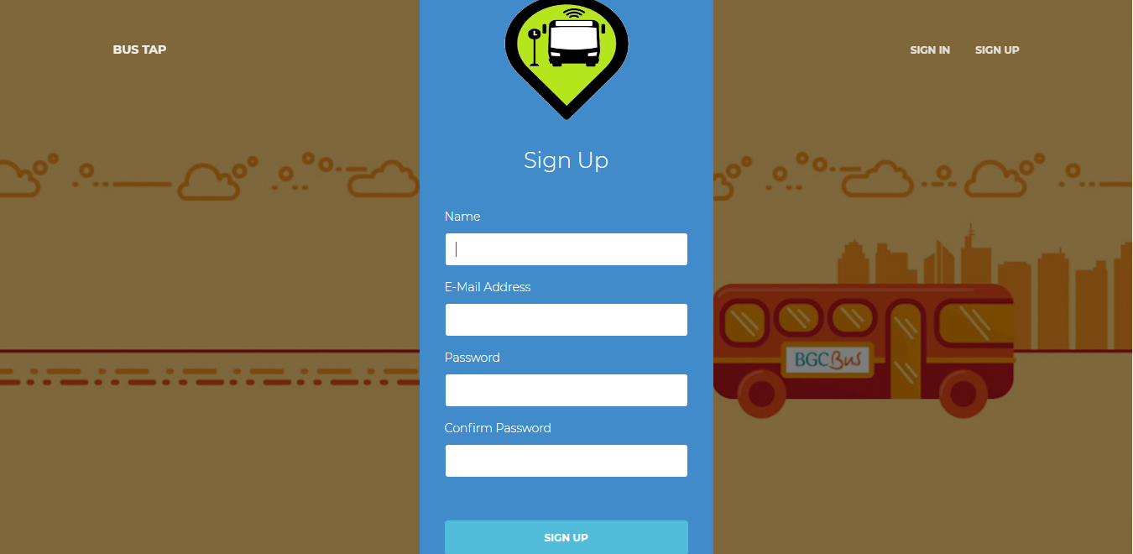

Figure 2. Screenshot of the SignUp Page of the Web Application

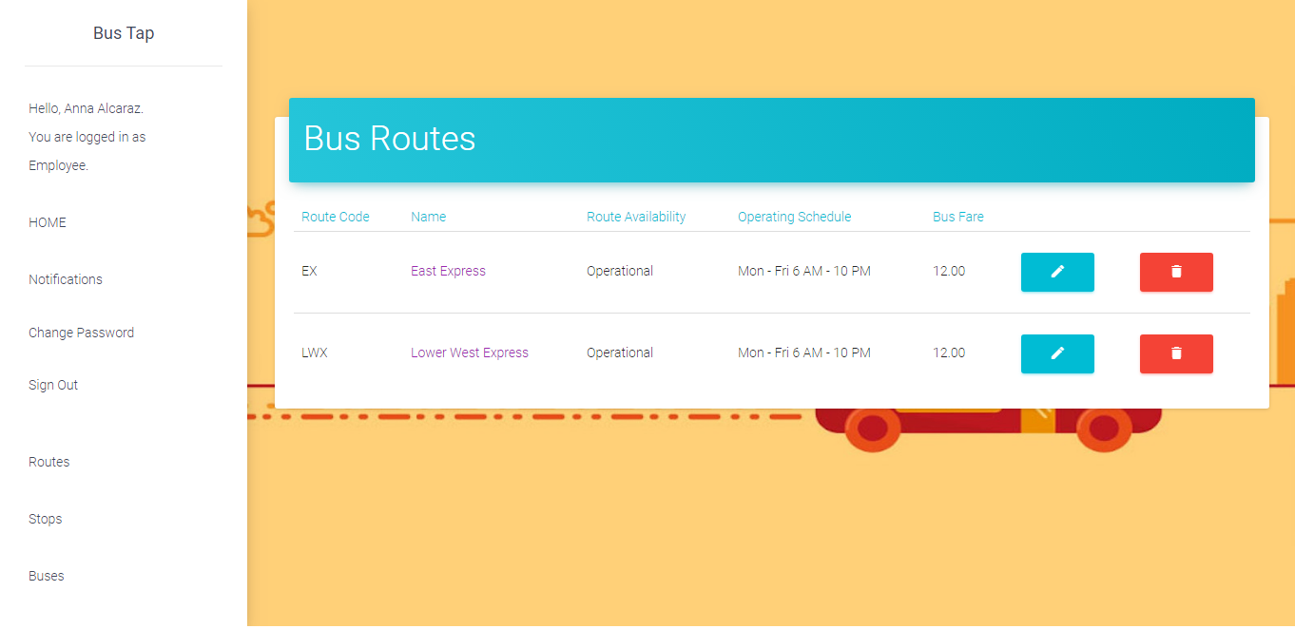

Figure 3. Screenshot of the View Routes Page of the Web Application

# Conclusions and Recommendations

The group created a mobile application as front-end and a web application as back-end for the Bus Tap, a passenger information system, that aims to connect the BGC Bus company to its passengers. Through the Bus Tap, the BGC Bus company can provide its passengers with the latest information regarding their services, and passengers can access up-to-date information regarding BGC Bus. Passengers can also contact the BGC Bus company through the mobile application, and provide rating, feedback, suggestions, or send inquiries, and receive replies.

With the Bus Tap reservation feature, passengers no longer have to wait long to be able to ride the bus, having been able to reserve a spot on their desired schedule ahead of time, minimizing the waiting time they experience when taking the BGC Bus.

# References

Obias, M. (2017, August 9). BGC Bus. (A. C. Alcaraz, S. M. Angot, J. V. Besmano, & J. G. Brioso, Interviewers)

Todd, A., & Barraclough, C. (2017, June 28). *What is Android OS*. Retrieved from recombu.com: https://recombu.com/mobile/article/what-is-android-and-what-is-an-android-phone\_M12615.html#

Trapeze Group. (n.d.). *Passenger Information Systems: What Transit Agencies Need To Know.* Retrieved from Trapeze Group Web site: http://www.trapezegroup.com/uploads/resources/Trapeze\_WP\_Passenger\_Info\_FIN.pdf

# Appendices

## Data Gathering

### Letter of Request for Interview to the management of the BGC Bus



3 August 2017

MR. JAIME FRANCISCO T. GALVEZ, JR.

General Manager

Bonifacio Transport Corporation

Utility Area 31st Street

Crescent Park West Bonifacio Global City

DEAR MR. GALVEZ:

Greetings!

We are 3rd year students of Asia Pacific College, under the BS Computer Science program, specializing in Systems Software. We are currently enrolled in an Introduction to Systems Analysis and Design (INTSDEV) course that requires students to complete an industry-based project of developing systems or applications for a company, government agency, or institution.

Public transportation, particularly the BGC Bus, has been the interest of our group. We aim to learn more about the business process of the BGC Bus, and to identify issues and problems encountered by the management and the passengers of the BGC Bus, to be able to propose a suitable system or application that will help not only the management of the BGC Bus, but also its passengers.

In this light, we would like to request for an interview with you or your representative on August 9, 2017 between 2:00-5:00PM in your office. We have at least 20 questions and might take about 45 minutes of the interviewer’s time. Attached herewith is the list of interview questions.

If you have some inquiries or clarifications, or if you would like to set the interview on a different date and time, please feel free to get in touch with our project manager, Anna Lynn Alcaraz, at 09998845654, or through e-mail at acalcaraz@student.apc.edu.ph.

Thank you in advance.

Sincerely,

|  |  |  |  |
| --- | --- | --- | --- |
| ANNA LYNN C. ALCARAZ  Project Manager | SAMMY BOY M. ANGOT  Team Member | JUSTIN V. BESMANO  Team Member | JOB G. BRIOSO  Team Member |

Noted by:

|  |  |
| --- | --- |
| MS. RHEA-LUZ VALBUENA  Course Instructor | MR. JUSTIN DAVID PINEDA  Project Adviser |

### Questions for the Interview with the management of the BGC Bus



**Interview Questions: Bonifacio Transport Corporation**

1. What is the daily average total number of passengers of the BGC Bus?
2. How many passengers ride the BGC Bus in every month? If possible, please specify for each month of the year.
3. What are the different bus routes of the BGC Bus?
4. Which route caters to the most number of passengers? Which route caters to the least number of passengers?
5. For each bus route, what are the operating hours?
6. What are the peak hours and off-peak hours? If peak hours and off-peak hours vary for each bus route, please specify.
7. For each bus route, how many buses are deployed during peak hours, and during off-peak hours?
8. Are the buses of the BGC Bus equipped with GPS? If yes, may the group be allowed to use the GPS for our app or system?
9. Are the buses of the BGC Bus equipped with CCTV? If yes, may the group be allowed to use the CCTV for our app or system?
10. Is there a fixed schedule for bus arrival and bus departure?
11. Between each bus, what is the time interval during peak hours, and during off-peak hours?
12. What is the average waiting time of passengers during peak hours, and during off-peak hours?
13. How much is the bus fare for each bus route?
14. Which bus stops or terminals have loading stations and/or ticket booths?
15. Are the bus stops or terminals equipped with CCTV? If yes, may the group be allowed to use the CCTV for our app or system?
16. Can a new mode of payment, other than the beep™ card, be allowed?
17. What are the problems or difficulties encountered by the BGC Bus?
18. What are the strategies employed to accommodate additional passengers during peak hours?
19. How are announcements regarding the operations of the BGC Bus posted to the public?
20. What technology is used by the BGC Bus to predict the number of minutes until the arrival of the next bus?

### Interview Transcript

Interviewer: Anna Lynn C. Alcaraz, Sammy Boy M. Angot, Justin V. Besmano, Job G. Brioso

Interviewee: Mr. Mike Obias, Assistant Operation Manager, BGC Bus

Date: August 9, 2017

Time: 4:00 PM

Venue: Bonifacio Transport Corporation

Utility Area 31st Street

Crescent Park West, Bonifacio Global City

(start of interview)

Interviewer: What is the daily average total number of passengers of the BGC Bus? How many passengers ride the BGC Bus in every month?

Interviewee: Right now, we have 44,000 passengers on weekdays, and half of that on weekends. So, during Saturdays and Sundays, 20,000. In a month, we have almost 1,000,000 passengers.

Interviewer: Which months have the highest number of passengers, and which months have the lowest number of passengers?

Interviewee: Before, during March to June, we have less passengers, compared to the other months because those months are usually the students’ summer vacation; however, because some universities moved the start of their academic calendar, we noticed a decrease in passengers during July to September. But the month with the lowest ridership is March because it has lots of holidays, like Holy Week. Whenever there is a long holiday, we always have the lowest ridership.

Interviewer: What are the different bus routes of the BGC Bus?

Interviewee: Just last Monday, August 7, we recently implemented improved bus routes for the BGC Bus. We have 7 new regular routes that run from 6AM to 10PM. Then, we also have the augmentation, or what we call the extension routes. These extension routes travel to places outside BGC, like Ayala, we call it Ayala Route or Ayala Express. The second one is Arca South. It travels from here to Arca. Then the third one is the North Route, though the North Route still travels within BGC, but the North is handled by Megaworld, unlike BGC, which is handled by FBDC Ayala.

Interviewer: Which route caters to the most number of passengers? Which route caters to the least number of passengers?

Interviewee: So far, the route with the highest recorded number of passengers is the West Route. It is the combination of the Upper West and Lower West. Before it was just the West Route, but we split it into Upper and Lower. The West side of BGC Bus is here, where the office of the BGC Bus is located, and the East part is Market! Market! The route with the least number of passengers is the route going to Kalayaan. We recently implanted this route, just two months ago. It only runs for 4 hours in the morning on weekdays. Right now, it only has 100 pax.

Interviewer: For each bus route, how many buses are deployed for each route?

Interviewee: The amount of buses deployed to each route depends on the availability. But right now, our fleet is composed of 51 buses. The route with the most buses being deployed to is the one with the highest ridership, the West, followed by the East, then the other routes.

Interviewer: What is the capacity of the bus?

Interviewee: The buses have perimeter seating. In has a seating capacity of 37 passengers, but the bus can accommodate 75 passengers comfortably. The maximum capacity of the bus is 90 passengers.

Interviewer: What are the peak hours and off-peak hours?

Interviewee: Peak hours apply to all the routes. Peak hours are 6AM to 10AM and 4PM to 8PM.

Interviewer: Are the buses of the BGC Bus equipped with GPS? If yes, may the group be allowed to use the GPS for our app or system?

Interviewee: All buses are equipped with GPS.

Interviewer: Are the buses of the BGC Bus equipped with CCTV? If yes, may the group be allowed to use the CCTV for our app or system?

Interviewee: The buses are not yet equipped with CCTV, but we are planning to equip them. The challenge is for real-time streaming. The plan is to equip each bus with 4 CCTVs. But the challenge is with the bandwidth.

Interviewer: Are the bus stops or terminals equipped with CCTV? If yes, may the group be allowed to use the CCTV for our app or system?

Interviewee: The terminals are equipped with CCTVs but some of the stops don’t. But aside from the CCTV of the BGC Bus, we also have the city CCTVs. These stops are within range of the city CCTVS.

Interviewer: Is there a fixed schedule for bus arrival and bus departure?

Interviewee: We have a fixed schedule.

Interviewer: Between each bus, what is the time interval during peak hours, and during off-peak hours? What is the average waiting time of passengers during peak hours, and during off-peak hours?

Interview: The standard waiting time is 10 minutes. Every passenger should only wait, at most, for 10 minutes. That’s our goal here. For the actual, it varies depending on the traffic, the speed of the bus.

Interviewer: How much is the bus fare for each bus route?

Interviewee: We have a fixed fare price of P12 for all routes, except for Arca South and Nuvali, but that’s because they’re extension routes.

Interviewer: Which bus stops or terminals have loading stations and/or ticket booths?

Interviewee: Only selected stops have ticket booths. We encourage the passengers to use the beep™ cards. However, for stops near government offices, we have to deploy ticket sellers. These government offices have visitors that do not regularly travel within BGC. We cannot insist they buy their own beep™ cards. Stops with ticket sellers are Bonifacio Stopover, RCBC, Nutriasia, BGC Bus Bonifacio One Technology Tower terminal, BGC Bus Ayala terminal, and BGC Bus Market! Market! terminal. beep™ cards can be reloaded at the terminals.

Interviewer: What are the problems or difficulties encountered by the BGC Bus?

Interview: Passenger complaints.

Interviewer: Can you cite examples of complaints the BGC Bus has received from the passengers?

Interview: Mostly, passengers complain about the long line of passengers during rush hours, about having to wait long for the buses to arrive, and about how few the buses going around are.

(end of interview)

### Survey Questionnaire

Good day!

We are 3rd year students of Asia Pacific College, under the BS Computer Science program, specializing in Systems Software. For our Introduction to Systems Analysis and Design (INTSDEV) course this term, our group has to conduct a survey on passengers of the BGC Bus, as part of our data gathering for our project.

We would like to ask you to answer the following questions.

Thank you for your cooperation.

\_\_\_\_\_\_\_\_\_\_\_\_\_\_\_\_\_\_\_\_\_\_\_\_\_\_\_\_\_\_\_\_\_\_\_\_\_\_\_\_\_\_\_\_\_\_\_\_\_\_\_\_\_\_\_\_\_\_\_\_\_\_\_\_\_\_\_\_\_\_\_\_\_\_\_\_

Survey Questions:

Why do you ride the BGC Bus? (check all that apply)

☐ to go to school

☐ to go to work

☐ to go home

☐ to go to the mall

☐ others, please specify: \_\_\_\_\_\_\_\_\_\_\_\_\_\_\_\_\_\_\_\_

How often do you ride the BGC Bus in a week? (check one only)

⚪️ I don't regularly ride the BGC Bus

⚪️ 1-5 times a week

⚪️ 6-10 times a week

⚪️ 11-15 times a week

⚪️ more than 15 times a week

What are the problems you encounter when riding the BGC Bus? (check all that apply)

☐ long queue when buying bus ticket or loading beep™ card

☐ long queue when waiting for the bus

☐ inaccurate bus schedules

☐ congestion of passengers inside the bus

☐ others, please specify: \_\_\_\_\_\_\_\_\_\_\_\_\_\_\_\_\_\_\_\_

How do you pay for the BGC Bus fare? (check all that apply)

☐ bus ticket

☐ beep™ card

If you buy tickets, how many minutes do you usually take to buy bus tickets? (check one only)

⚪️ less than a minute

⚪️ 1-2 minutes

⚪️ 3-4 minutes

⚪️ 5 minutes or more

If you use the beep™ card, where do you load your beep™ card? (check all that apply)

☐ LRT stations

☐ MRT stations

☐ BGC Bus Ayala terminal

☐ BGC Bus Market! Market! terminal

☐ BGC Bus Bonifacio One Technology Tower terminal

☐ FamilyMart

☐ Circle K

☐ SM malls

How many minutes do you usually have to wait before boarding the bus? (check one only)

⚪️ 1-5 minutes

⚪️ 6-10 minutes

⚪️ 11-15 minutes

⚪️ 16-20 minutes

⚪️ 21-25 minutes

⚪️ 25-30 minutes

⚪️ more than 30 minutes

Will an app for the BGC Bus be useful to you? (check one only)

⚪️ yes

⚪️ no

What features of a BGC Bus app will be useful to you? (check all that apply)

☐ the app can give users step-by-step directions from origin to direction, with estimated travel time and fare

☐ the app can display a map indicating all bus routes, including stops and nearby landmarks for each bus route

☐ the app can display nearby locations of beep™ card loading stations on the map

☐ the app can display bus arrival times and departure times

☐ the app can display how many minutes until the next bus arrives at the bus stop

☐ the app can show the real-time location of the buses on the map

☐ users can check how long the lines are at each bus stop

☐ users can check the remaining balance on their beep™ card

☐ users can use their cellphone load to pay for the bus far

|  |  |  |
| --- | --- | --- |
| **Name:** | **ANNA LYNN C. ALCARAZ** | **2x2 CORPORATE photo**  Must fit in this box.  Strictly corporate attire. |
| **Complete Address:** | 37 Circle Drive, Cubic Homes |
| Merville, Parañaque |
| **Contact Number/s:** | Landline: 8220429 |
| Mobile No.: (0999) 884-5654 |
| **Email Address:** | [acalcaraz@student.apc.edu.ph](mailto:smangot@student.apc.edu.ph)  [annalynn.alcaraz@gmail.com](mailto:angot.sammy@gmail.com) |
| **Website:** | https://www.linkedin.com/in/anna-lynn-alcaraz/ |

|  |  |
| --- | --- |
| **Personal Statement** | Currently the Project Manager of Bus Tap, Web Developer of TaraNaSaPinas, and SQA Team Project Manager of Guru-App  Knowledgeable in C++, Java, Python, Ruby, HTML, CSS, and PHP |
| **Education** | **Asia Pacific College**, Magallanes, Makati City  **B.S. Computer Science Major in Systems Software**  January 2015-present |
| **Work-Related Courses** | * Database Management * Web Development * Systems Analysis and Design * Software Development * Project Management |
| **Academic Projects** | **Bus Tap**   * Passenger information system for the Bonifacio Global City (BGC) Bus * June 2017 – April 2018 * Project Manager   **TaraNaSaPinas**   * Mobile and web application where travel agencies can post travel deals and travellers can book travel deals * January 2018 – April 2018 * Web Developer   **Guru App**   * Web application where School HR can post jobs and where full-time/part-time teachers can search for job positions * January 2018 – April 2018 * SQA Team Project Manager |
| **Technical Skills** | * Knowledgeable in Database Administration, Systems Analysis and Design, Software Development, Project Management |
| **Awards & Recognitions** | * Dean’s Lister, AY 2017-2018 |

|  |  |  |
| --- | --- | --- |
| **Name:** | **SAMMY BOY M. ANGOT** | **2x2 CORPORATE photo**  Must fit in this box.  Strictly corporate attire. |
| **Complete Address:** | 52 Ranger Street, South Signal Village, |
| Taguig City |
| **Contact Number/s:** | Landline: 837-7418 |
| Mobile No.: (0916) 697-8145 |
| **Email Address:** | [smangot@student.apc.edu.ph](mailto:smangot@student.apc.edu.ph)  [angot.sammy@gmail.com](mailto:angot.sammy@gmail.com) |
| **Website:** | <https://sg.linkedin.com/in/sammy-angot-284a7515b> |

|  |  |
| --- | --- |
| **Personal Statement** | Currently the Logistics Team Assistant Head of the APC Microsoft Community who is eager to accomplish work with compliance to a minimum time allotted and ensures what needs to be done. Humble and flexible to any teams that to be assigned.  Skilled in using Adobe Photoshop, Adobe Illustrator, Adobe Aftereffect, Adobe Dreamweaver, Android Studio and Vegas Pro, specializing for work presentations, system production and debugging maintenance, and multimedia creation for outsourcing clients. |
| **Education** | **Asia Pacific College**, Magallanes, Makati City  **B.S. Computer Science Major in Systems Software**  June 2015-present |
| **Work-Related Courses** | * Web Development * Mobile Development * Business Analysis |
| **Academic Projects** | **McShield**   * Anti-Malware Software,June. 2012 * Introduced to APC to be the standard anti-malware software * Documentation Head * Used as the standard by the APC School of Computing and Information Technologies, June 2016   **Smart Trash Can**   * Arduino-based microcontrollers and sensors * Functional prototype to send SMS to waste management authorities if trash bins are full * Prototype Assembly   **Bonifacio Global City (BGC) Bus Passenger Information System: Bus Tap**   * Mobile application that helps commuters riding the BGC Bus. * June 2017 – April 2018 * Project Analyst * Chosen to Exhibit Project in Merge 2.0, April 2018 |
| **Technical Skills** | * Highly skilled in Software Development and Multimedia * Intermediate skills in Programming and Video Production * Proficient in MS Office: Word, Excel, PowerPoint * Sufficient knowledge in System Design |
| **Certifications** | * N/A |
| **Awards & Recognitions** | * N/A |
| **Seminars & Trainings Attended** | * Xamarin Workshop, Asia Pacific College, July 2016 * Internet of Things Seminar, Asia Pacific College, July 2017 * Xamarin Workshop, Asia Pacific College, July 2017 * Introduction to Azure Seminar, Asia Pacific College, July 2017 * How to be successful in Pitching Idea Seminar, July 2017 * Cognitive Services and Internet of Things Seminar, Asia Pacific College, July 2017 * Imagine Cup Seminar, Asia Pacific College, July 2017 |
| **Extra-Curricular Activities** | * Gaming Genesis, Member, SY 2015-2016 * Junior Philippine Computer Society, Member, SY 2015-2017 * APC Microsoft Community, Logistics Team Assistant Head, SY 2017-present |

|  |  |  |
| --- | --- | --- |
| **Name:** | **Justin V. Besmano** | C:\Users\jvbesmano\AppData\Local\Microsoft\Windows\INetCache\Content.Word\29852468_1720297984695188_565014887_n.jpg  . |
| **Complete Address:** | 676 E. Rodriguez Street, Malibay, |
| Pasay City |
| **Contact Number/s:** | Landline: N/A |
| Mobile No.: (0917) 333-9604 |
| **Email Address:** | [jvbesmano@student.apc.edu.ph](mailto:jvbesmano@student.apc.edu.ph)  [jvbesmano@gmail.com](mailto:jvbesmano@gmail.com) |
| **Website:** | [www.linkedin.com/in/justin-besmano/](file:///C:\Users\acalc\Downloads\www.linkedin.com\in\justin-besmano\) |

|  |  |
| --- | --- |
| **Personal Statement** | A recent student of Asia Pacific College, achieving good grades in math and science related courses, who is looking to have a career as a system software analyst and/or developer to use and further develop my analytical and critical thinking ability.  A highly motivated individual who is into Project Management and Software development, has a good work ethic and an enthusiastic person who enjoys challenges in achieving personal and team goals.  Highly Skilled in web and mobile programming, especially android development for mobile and frameworks for web, proficient in web design, with proficient knowledge in JavaScript and CSS |
| **Education** | **Asia Pacific College**, Magallanes, Makati City  **BS Computer Science Major in Systems Software**  June 2015-present |
| **Work-Related Courses** | * Programming * Research * Software development * System Analysis |
| **Academic Projects** | **BGC Bus: Passenger Bus Information System**   * Bus Tap,April 2018 * Mobile Application * Lead Mobile Developer * Included in APC’s Merge 2.0 exhibit   **Eat-ToDo-Mo: Carinderia Finder**   * Carinderia Finder Application * January – April 2018 * Lead Developer   **Community Portal Application**   * Community portal web application * September – January 2018 * Project Manager |
| **Technical Skills** | * Highly skilled in Java Programming * Proficient in MS Office: Word, Excel, PowerPoint * Proficient in python, ruby programming language * Proficient in Web and Mobile Design |
| **Certifications** |  |
| **Awards & Recognitions** | * 4th Place, ORSP National Congress Quiz Bee, March 2017 * Dean’s List, Academic Year 2016-2017 * Dean’s List, Academic Year 2017-2018 |
| **Seminars & Trainings Attended** | * Operations Research Society of the Philippines National Congress, March 2017 |
| **Extra-Curricular Activities** | * Microsoft Community, Member, SY 2017-present * Junior Philippine Computer Society, Member, SY 2016-2017 |

|  |  |  |
| --- | --- | --- |
| **Name:** | **Job G. Brioso** | C:\Users\Ynna Brioso\Downloads\29920663_2080475412195979_1821235219_n.jpg  . |
| **Complete Address:** | MB 14 Unit 506 BCDA Diego Silang Village |
| Taguig City |
| **Contact Number/s:** | Landline: N/A |
| Mobile No.: (0956) 432 0167 |
| **Email Address:** | [jgbrioso@student.apc.edu.ph](mailto:jgbrioso@student.apc.edu.ph)  briosojob@gmail.com |
| **Website:** | N/A |

|  |  |
| --- | --- |
| **Personal Statement** | Presently a student of Asia Pacific College and is preparing to have a career in Systems development to enhance the knowledge that I have learn during my college years.  A team player and result oriented, ensuring that every task given is executed properly and efficiently.  Knowledgeable in information technology and software development proficient in web design, with experience knowledge in JavaScript and CSS. Hoping to pursue a fruitful career in the above mentioned proficiencies and subjects to be recognized as a proficient programmer from the reputed Asia Pacific College. |
| **Education** | **Asia Pacific College**, Magallanes, Makati City  **BS Computer Science Major in Systems Software**  June 2015-present |
| **Work-Related Courses** | * Programming * Research * Software development * System Analysis |
| **Academic Projects** | **BGC Bus: Passenger Bus Information System**   * Bus Tap,April 2018 * Included in APC’s Merge 2.0 exhibit |
| **Technical Skills** | * Highly skilled in Java Programming * Proficient in MS Office: Word, Excel, PowerPoint |
| **Certifications** | N/A |
| **Awards & Recognitions** | N/A |
| **Seminars & Trainings Attended** | N/A |
| **Extra-Curricular Activities** | * Junior Philippine Computer Society, Member, SY 2016-2017 |